|  |
| --- |
|  |
| Capstone Event Document |

**WingS**

Report #2 – Screen Design

|  |  |  |
| --- | --- | --- |
| **WingS** | | |
| **Group Members** | Đào Trọng Nghĩa | SE03220 |
| Lê Hồng Nhiên | SE03377 |
| Tạ Ngọc Duy | SE03267 |
| Đỗ Văn Tuấn | SE03297 |
| Hoàng Tuấn Anh | SE03108 |
| **Supervisor** | Mr. Nguyễn Văn Sang | |
| **Event code** | WS | |

**- Hanoi, 09/2016 -**

# SIGNATURE PAGE

AUTHOR: Tạ Ngọc Duy 06/09/2016

Team member

REVIEWERS: Đào Trọng Nghĩa 07/09/2016

Event manager

APPROVAL: Nguyễn Văn Sang --/--/--16

Supervisor

Record of change

*A - Added M - Modified D – Deleted

|  |  |  |  |  |  |
| --- | --- | --- | --- | --- | --- |
| Effective Date | Changed Item | A,M,D | Change Description | Reason for Change | Rev. Number |
| 07/Sep/2016 | Create Screen Design | A | First version | Create Screen Design | 1.0 |
|  |  |  |  |  |  |
|  |  |  |  |  |  |
|  |  |  |  |  |  |
|  |  |  |  |  |  |
|  |  |  |  |  |  |
|  |  |  |  |  |  |
|  |  |  |  |  |  |
|  |  |  |  |  |  |
|  |  |  |  |  |  |
|  |  |  |  |  |  |
|  |  |  |  |  |  |
|  |  |  |  |  |  |
|  |  |  |  |  |  |
|  |  |  |  |  |  |
|  |  |  |  |  |  |
|  |  |  |  |  |  |
|  |  |  |  |  |  |
|  |  |  |  |  |  |
|  |  |  |  |  |  |
|  |  |  |  |  |  |
|  |  |  |  |  |  |
|  |  |  |  |  |  |

Table of Contents

SIGNATURE PAGE 1

Introduction 3

1.1 Purpose 3

1.2 Definitions, Acronyms and Abbreviations 3

1.3 Overview 3

2 Screen flow 4

2.1 User 4

2.2 Administrator 5

3 Screen design 6

3.1 Register 6

3.2 Login 7

3.3 Searching 8

3.4 View 10

3.5 Create event 11

3.6 Event detail 14

3.7 Create Thread 17

3.8 Thread detail 18

3.9 User Information 19

3.10 Message 27

3.11 Donate 30

3.12 ADMIN 31

# Introduction

## Purpose

To ensure consistency and simplicity in detailed design across all displays within a product interface, as well as across other products used by the same users. Definitions, acronyms, abbreviations, references and overview of WS website.

## Definitions, Acronyms and Abbreviations

|  |  |  |
| --- | --- | --- |
| Abbreviations | Description | Comment |
| WS | WingS |  |
| Q&A | Question and Answer |  |

1. Definitions, Acronyms and Abbreviations

## Overview

This document contains the subsections: Screen flow and Screen design

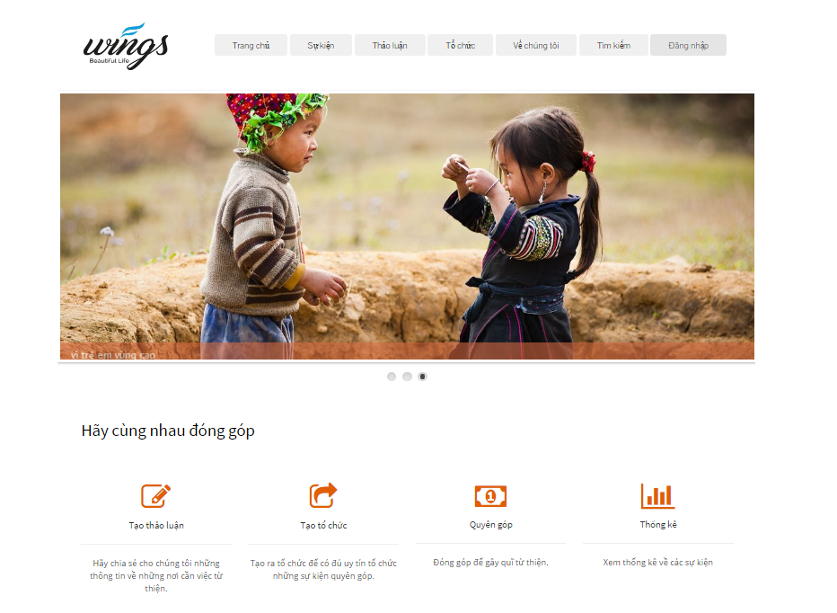

# Screen flow

## User

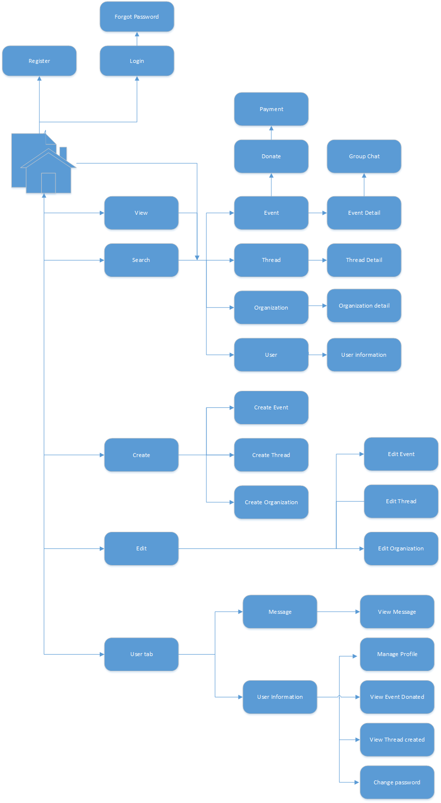

1. Client screen flow

## Administrator

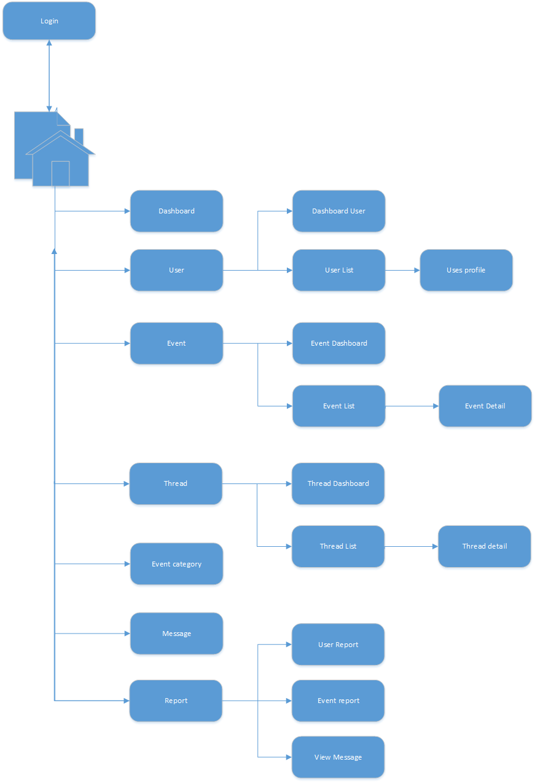

1. Admin screen flow

# Screen design

## Register

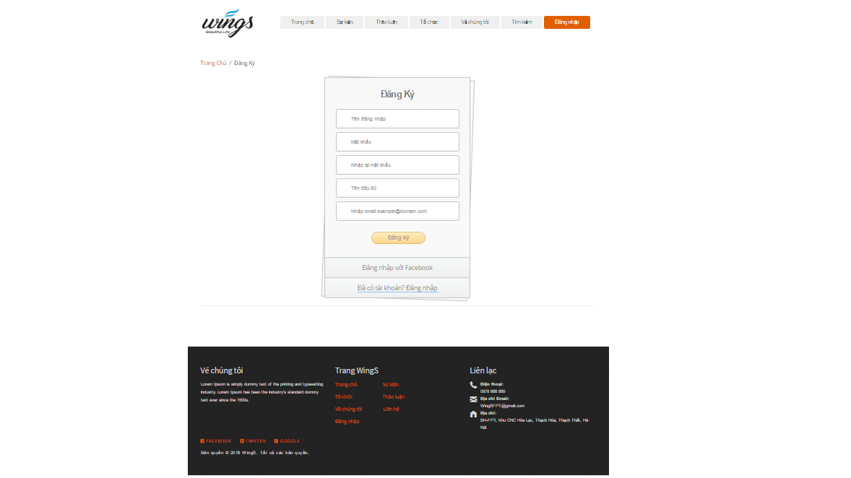

1. R**egister screen**

|  |  |  |  |  |  |  |  |
| --- | --- | --- | --- | --- | --- | --- | --- |
| No | Field name | Field name in Vietnamese | Type | Require | Mandatory | Max-Length | Description |
|  | Register | Đăng ký | Label |  | Y |  | Display register form |
|  | AccountName | Tên hiển thị | Text box | Type | Y | 8-20 | Name of user |
|  | Username | Tên tài khoản | Text box | Type | Y | 8-20 | Username of user |
|  | Password | Mật khẩu | Text box | Type | Y | 8-50 | Password of user |
|  | Confirm Password | Nhập lại mật khẩu | Text box | Type | Y |  | User retype password |
|  | Email | Email | Textbox | Type | Y |  | Email of user |
|  | Sign up | Đăng ký | Button | Click | Y |  | User register a new account |
|  | Login now | Đăng nhập ngay | Hyperlink | Click | Y |  | Login when user have an account |

1. R**egister** screen

## Login

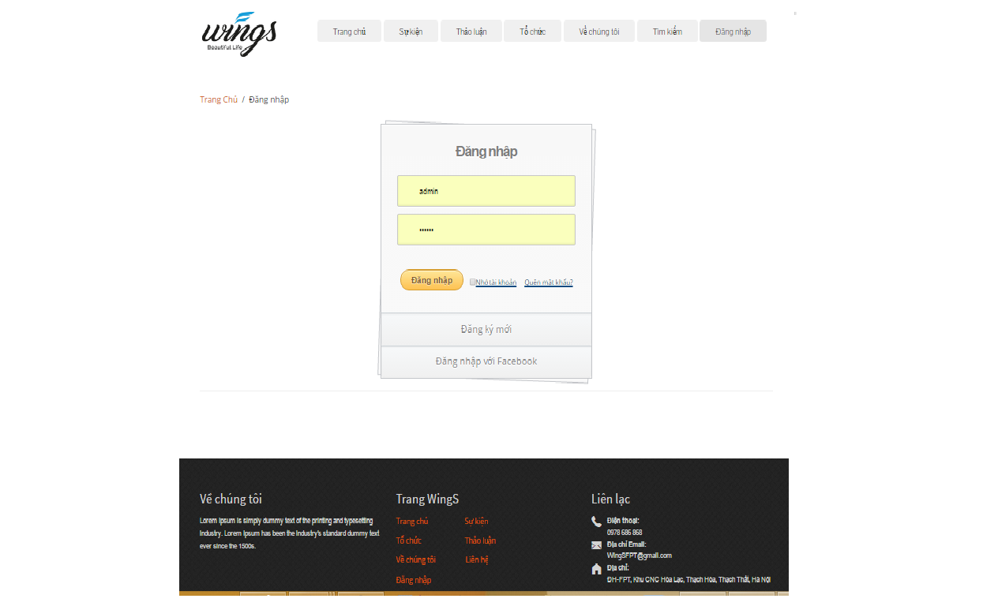

1. Login **screen**

|  |  |  |  |  |  |  |  |
| --- | --- | --- | --- | --- | --- | --- | --- |
| No | Field name | Field name in Vietnamese | Type | Require | Mandatory | Max-Length | Description |
|  | Username | Tên đăng nhập | Text box | Type | Y |  | Username of registered user |
|  | Password | Mật khẩu | Text box | Type | Y |  | Password of registered user |
|  | Remember Me | Lưu đăng nhập | Check box | Click | Y |  | Save login information |
|  | Login | Đăng nhập | Button | Click | Y |  | Login |
|  | Forgot Password | Quên mật khẩu | Hyperlink | Click | Y |  | Resend password to user |
|  | Register now | Đăng ký | Hyperlink | Click | Y |  | Register when user have not an account |
|  | Login with Facebook | Đăng nhập qua Facebook | Button | Click | Y |  | Login with Facebook |

1. Loginscreen

## Searching

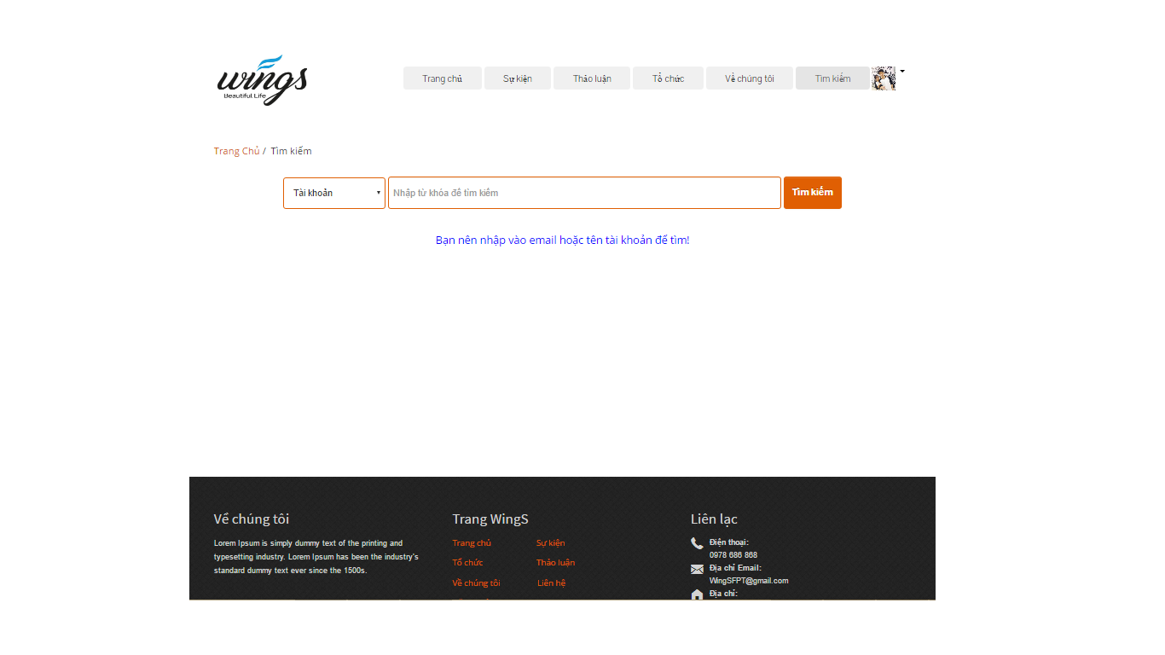

1. Searching screen design

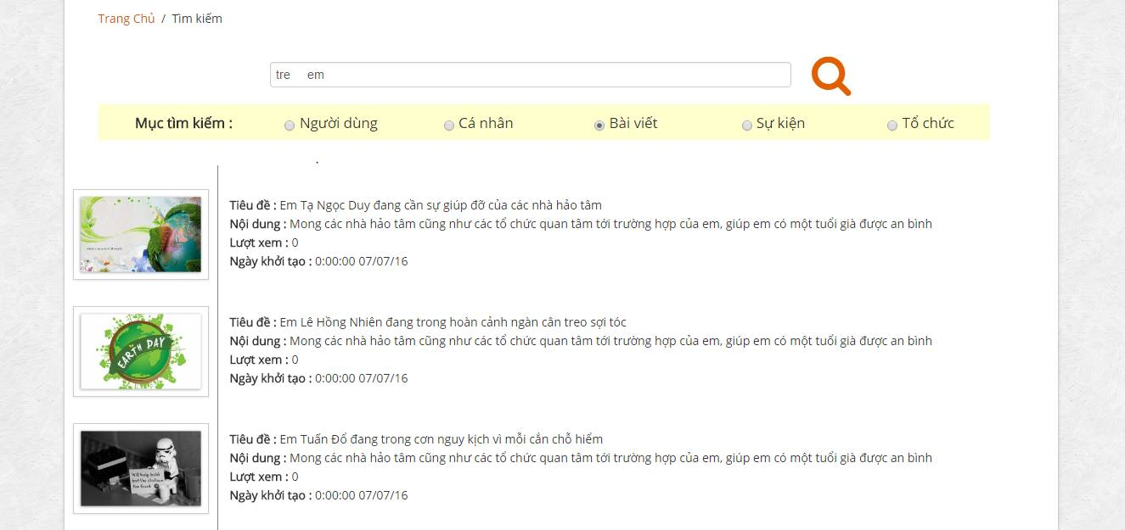

1. Search Event result screen design

|  |  |  |  |  |  |  |  |
| --- | --- | --- | --- | --- | --- | --- | --- |
| No | Field name | Field name in Vietnamese | Type | Require | Mandatory | Max-Length | Description |
| 1 | Search box | Ô tìm kiếm | Text |  | Y |  | Display text |
| 2 | Search icon |  | Button | Click | Y |  | Search Event |
| 2 | Search type | Mục tìm kiếm | Label |  | Y |  | Display search type |
| 3 | Event | Sự kiện | Drop down list | Click | Y |  | Filter by category of Events |
| 4 | User | Cá nhân | Drop down list | Click | Y |  | Filter by status of Events |
| 5 | User | Cá nhân | Drop down list | Click | Y |  | Filter by status of Events |
| 6 | Thread | Bài viết | Drop down list | Click | Y |  | Filter by status of Events |
| 7 | Organization | Tổ chức | Drop down list | Click | Y |  | Filter by status of Events |
| 8 | List result | Kết quả | List |  |  |  | Display list result |

1. Searchscreen

## View

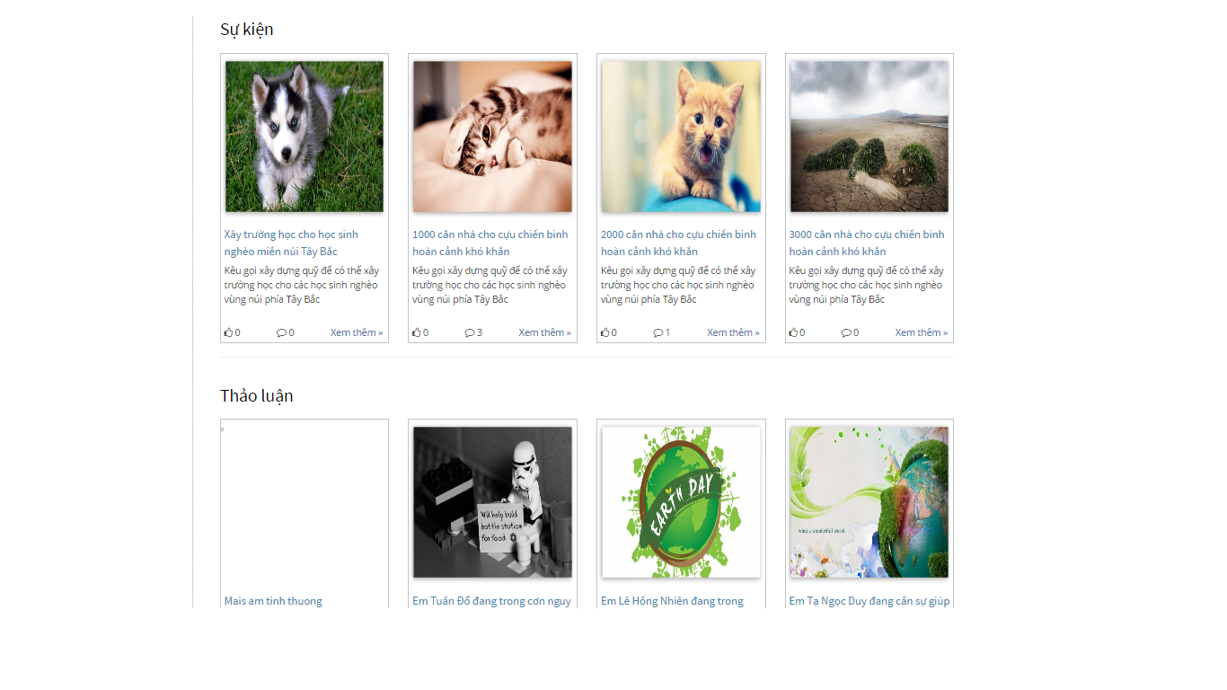

1. Home viewscreen

|  |  |  |  |  |  |  |  |
| --- | --- | --- | --- | --- | --- | --- | --- |
| No | Field name | Field name in Vietnamese | Type | Require | Mandatory | Max-Length | Description |
| 1 | Event | Event | Label |  | Y |  | Label display “Event” |
| 2 | List event | Danh sách các Event | List |  | Y |  | Display list of event |
| 3 | Thread | Thảo luận | Label |  | Y |  | Label display “Thảo luận” |
| 5 | List thread | Danh sách các bài thảo luận | List |  | Y |  | Display list of thread |
| 6 | Organization ranking | Xếp hạng các tổ chức | Label |  | Y |  | Label display “Xếp hạng các tổ chức” |
| 7 | List highest ranking | Các tổ chức xếp hạng cao nhất | List |  | Y |  | Display 3 of highest rank organization |
| 8 | View ranking | Xem xếp hạng | Button |  | Y |  | Button display “Xem xếp hạng” |

1. Home viewscreen

## Create event

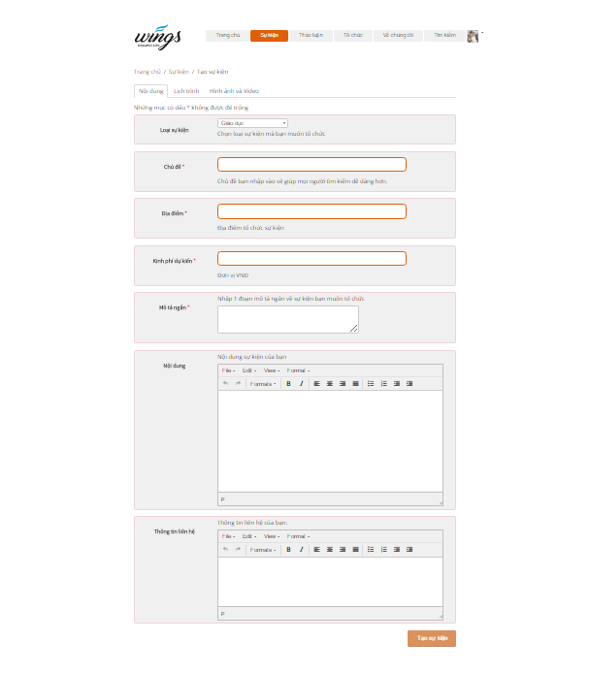

1. Create event screen (Content)

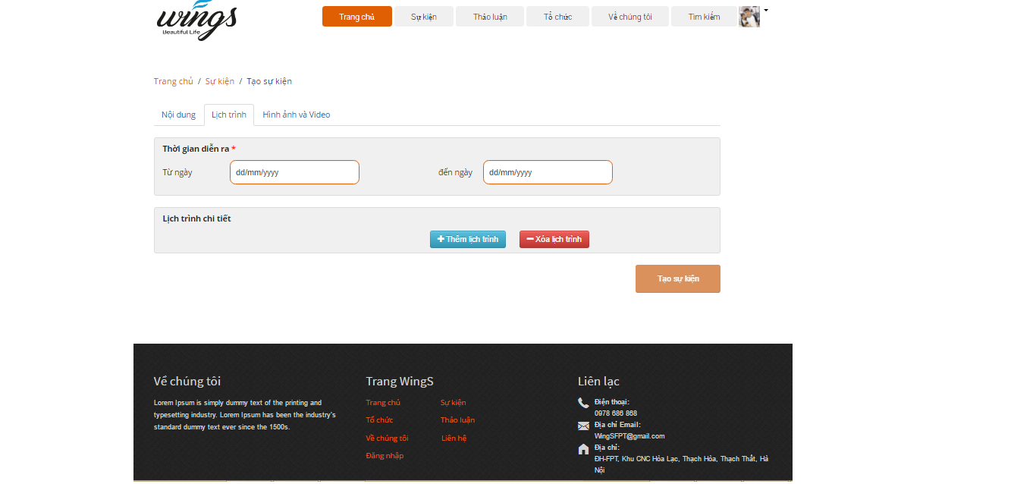

1. Create event screen (Schedule)

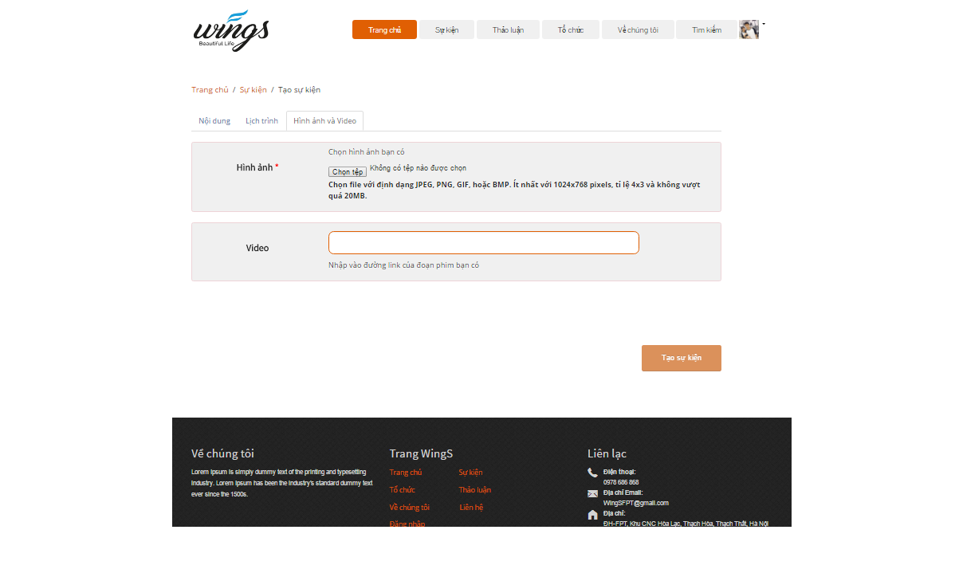

1. Create event screen (Pictures and videos)

|  |  |  |  |  |  |  |  |
| --- | --- | --- | --- | --- | --- | --- | --- |
| No | Field name | Field name in Vietnamese | Type | Require | Mandatory | Max-Length | Description |
| 1 | Content | Nội dung | Tab | Click | Y |  | Content of event |
| 2 | Warning | Những mục có dấu * không được để trống |  |  |  |  | The warning about the necessary field |
| 3 | Event category | Loại Event | DropdownList | Click | Y |  | Choose a category of event |
| 4 | Event name | Chủ đề | Text |  | Y | 100 | Name of event |
| 5 | Location | Địa điểm | Text |  | Y |  | Location of event |
| 6 | Short description | Mô tả ngắn | Text |  | Y |  | Description of event |
| 7 | Content | Nội dung | Text |  | Y |  | Event’s content |
| 8 | Contact | Thông tin liên hệ | Button | Button | Y |  | Contact to creater |
| 9 | Schedule | Lịch trình |  | Click |  |  |  |
| 10 | Time of event | Thời gian diễn ra | Label |  |  |  | Time of event |
| 11 | Start date | Từ ngày | Date/Time | Click | Y |  | Starting date of event |
| 12 | End date | Đến ngày | Date/Time | Click | Y |  | End date of event |
| 13 | Description | Mô tả | Text |  |  |  | Desctiption of schedule |
| 14 | Pictures and videos | Hình ảnh và video | Label |  |  |  | Pictures and videos tab |
| 15 | Pictures | Hình ảnh | Button |  | Y |  | Pictures of event |
| 16 | Videos | Videos | URL/text |  |  |  | Videos of event |

1. Create Event screen

## Event detail

### Event detail

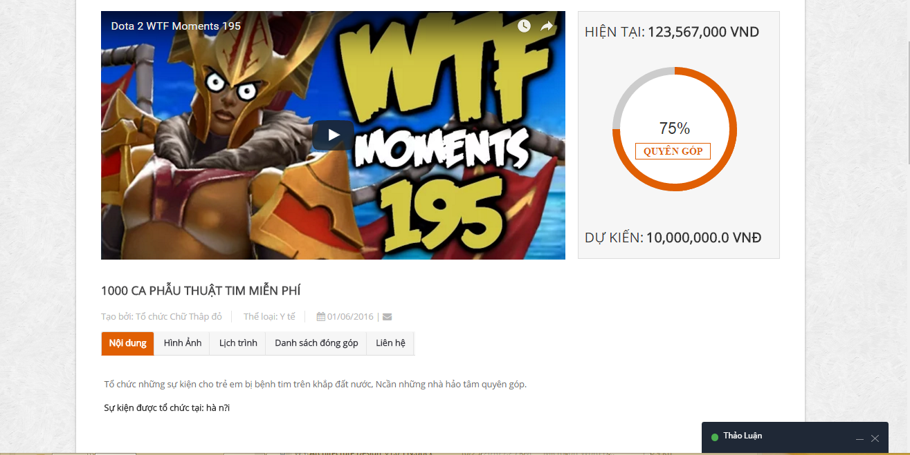

1. Event detail

|  |  |  |  |  |  |  |  |
| --- | --- | --- | --- | --- | --- | --- | --- |
| No | Field name | Field name in Vietnamese | Type | Require | Mandatory | Max-Length | Description |
| 1 | Name of Event | Tên Event | Label |  | Y |  | Name of event |
| 2 | Name of creator | Tên người gây quỹ | Label |  | Y |  | Name of creator |
| 3 | Category | Thể loại | Label |  | Y |  | Category of Event |
| 4 | Created date | Ngày tạo | Label |  | Y |  | Created date |
| 5 | Send massage | Gửi tin nhắn | Icon |  | Y |  | Send massage to organization |
| 6 | Content | Nội dung | Tab | Click | Y |  | Content of Event |
| 7 | Pictures | Hình ảnh | Tab | Click | Y |  | Pictures of Event |
| 8 | Schedule | Lịch trình | Tab | Click | Y |  | Schedule of Event |
| 9 | List of donor | Danh sách đóng góp | Tab | Click | Y |  | List of donor to event |
| 10 | Tab contact | Liên hệ | Tab | Click | Y |  | Display contact information of event |
| 12 | Donate | Đóng góp | Button | Click | Y |  | Display comment of event |
| 13 | Join in | Tham gia | Button |  |  |  | Join in event |
| 14 | Like | Thích | Button |  |  |  | Like event |
| 15 | Share | Chia sẻ | Button |  |  |  | Share event |
|  |  |  |  |  |  |  |  |

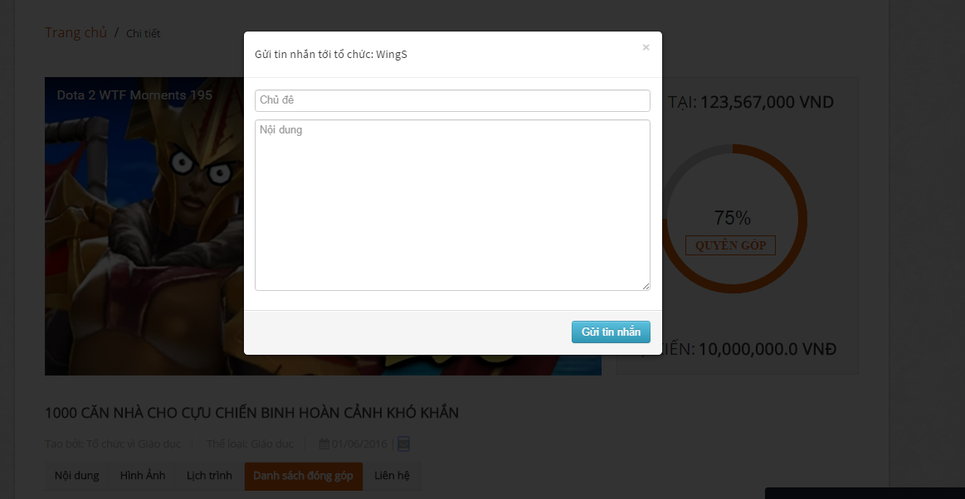

1. Sent report, question screen

|  |  |  |  |  |  |  |  |
| --- | --- | --- | --- | --- | --- | --- | --- |
| No | Field name | Field name in Vietnamese | Type | Require | Mandatory | Max-Length | Description |
| 2 | Sent a question | Gửi tin nhắn | Icon | Click | Y |  | Sent a question to creator’Event |
| 3 | Popup Sent message | Popup tin nhắn | Popup |  |  |  | Display popup sent message when click “Message” icon |
| 4 | Report this event | Báo cáo sai phạm | Button | Click | Y |  | Report Event |
| 5 | Popup Report this event | Popup Báo cáo Event | Popup |  |  |  | Display popup report event when click “Report” icon |

1. Sent report, question

### Update event

### Comment

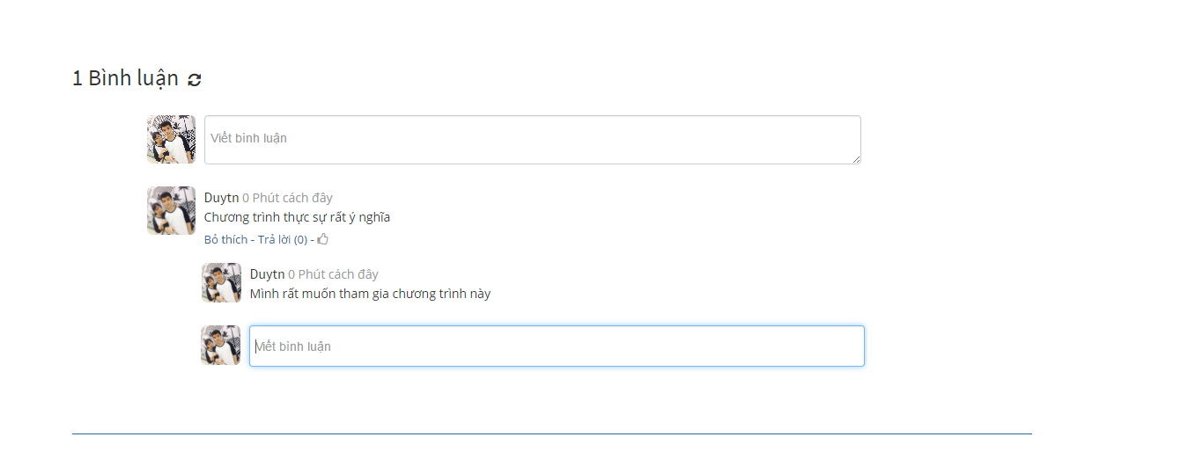

1. Comment area

|  |  |  |  |  |  |  |  |  |
| --- | --- | --- | --- | --- | --- | --- | --- | --- |
| No | | Field name | Field name in Vietnamese | Type | Require | Mandatory | Max-Length | Description |
| 1 | List comments | | Bình luận | List |  | Y |  | Display list comment |
| 2 | Input comment | | Nhập bình luận… | Textarea |  | Y | 100 | Display content of comment. |
| 3 | Reply | | Trả lời | Button | Click | Y | 100 | Sent a reply to comment. |
| 5 | Refresh | | Tải lại bình luận | Button | Click |  |  | Refresh all comments. |

1. Comment area

## Create Thread

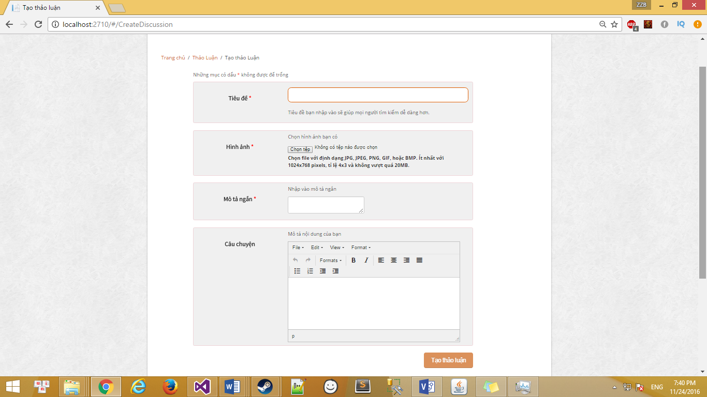

1. Create thread screen

|  |  |  |  |  |  |  |  |
| --- | --- | --- | --- | --- | --- | --- | --- |
| No | Field name | Field name in Vietnamese | Type | Require | Mandatory | Max-Length | Description |
| 1 | Warning | Những mục có dấu * không được để trống | Text |  | Y |  | The warning about the necessary field |
| 2 | Thread Title | Chủ đề | Text |  | Y | 100 | Title of thread |
| 3 | Pictures | Hình ảnh | Button |  | Y |  | Pictures of thread |
| 4 | Short description | Mô tả ngắn | Text |  | Y |  | Description of thread |
| 5 | Content | Nội dung | Text |  | Y |  | Thread’s content |

1. Comment area

## Thread detail

### Thread detail

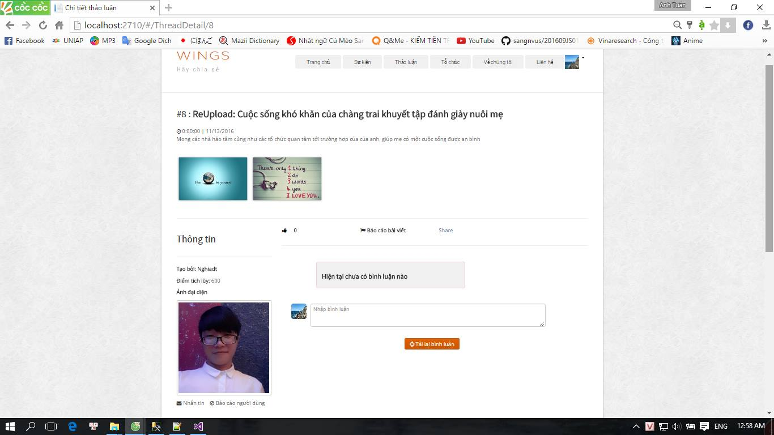

1. Thread detail

|  |  |  |  |  |  |  |  |
| --- | --- | --- | --- | --- | --- | --- | --- |
| No | Field name | Field name in Vietnamese | Type | Require | Mandatory | Max-Length | Description |
| 1 | Title of Thread | Tiêu đề | Label |  | Y |  | Title of thread |
| 2 | Date/time created | Thời gian tạo | Label |  | Y |  | Date/time created of thread |
| 3 | Content | Nội dung | Label |  | Y |  | Content of Thread |
| 4 | Creator information | Thông tin người tạo | Label |  | Y |  | Creator information |
| 5 | Creator name | Tên người tạo | Label |  | Y |  | Creator name |
| 6 | Point | Điểm tích lũy | Label |  | Y |  | Activities point of creator |
| 7 | Avatar | Ảnh người tạo | URL link |  | Y |  | Avatar of creator |
| 8 | Like | Thích | Icon | Click | Y |  | Like thread button |
| 9 | Report | Báo cáo bài thảo luận | Icon | Click | Y |  | Report thread button |
| 10 | Comment list | Bình luận | Label |  | Y |  | Display all comment of thread |
| 12 | Comment | Viết bình luận | Text |  | Y |  | Write comment |
| 13 | Reload comment | Tải bình luận | Button |  |  |  | Reload comment |

1. Thread detail table

### Edit thread

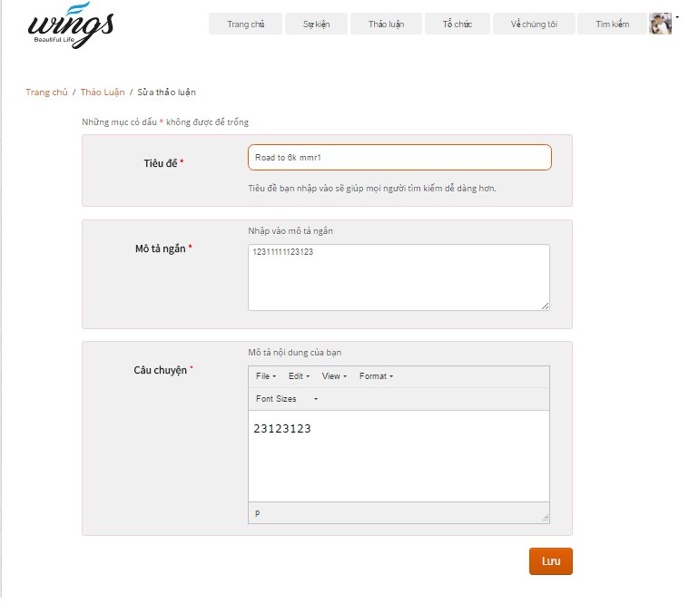

1. Edit thread screen

|  |  |  |  |  |  |  |  |
| --- | --- | --- | --- | --- | --- | --- | --- |
| No | Field name | Field name in Vietnamese | Type | Require | Mandatory | Max-Length | Description |
| **2** | Warning | Những mục có dấu * không được để trống | Text |  | Y |  | The warning about the necessary field |
|  | Title | Tiêu đề | Text |  | Y |  | The title of thread |
|  | Short description | Mô tả ngắn | Text |  | Y |  | Short description of thread |
|  | Content | Câu chuyện | Text |  | Y |  | Content of thread |
|  | Save | Lưu | Button | Click | Y |  | Save thread |

1. Edit thread table

## Create Organization

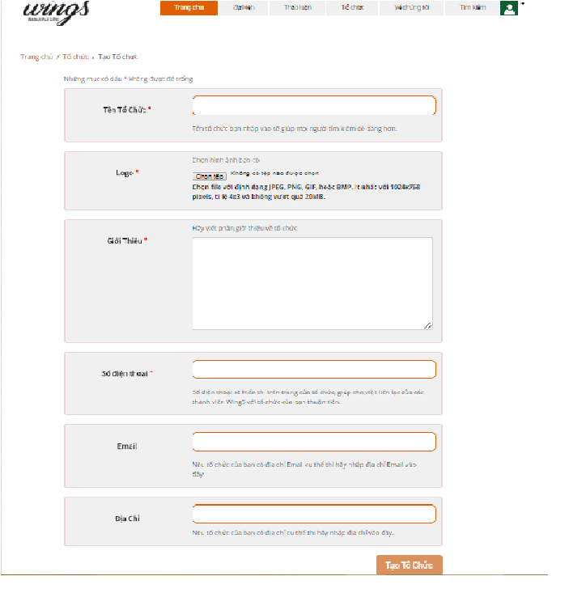

1. Create thread screen

|  |  |  |  |  |  |  |  |
| --- | --- | --- | --- | --- | --- | --- | --- |
| No | Field name | Field name in Vietnamese | Type | Require | Mandatory | Max-Length | Description |
| 1 | Warning | Những mục có dấu * không được để trống | Text |  | Y |  | The warning about the necessary field |
| 2 | Logo | Logo | Button |  | Y |  | Logo of organization |
| 3 | Introduction | Giới Thiệu | Text |  | Y |  | Introduction about organization |
| 4 | Phone Number | Mô tả ngắn | Text |  | Y |  | Phone number |
| 5 | Email | Email | Text |  | Y |  | Email contact |
| 6 | Address | Địa chỉ | Text |  | Y |  | Address |
| 7 | Create Organization | Tạo sự kiện | Button | Click | Y |  | Create an organization |

1. Create organization

## Organization detail

### Organization detail

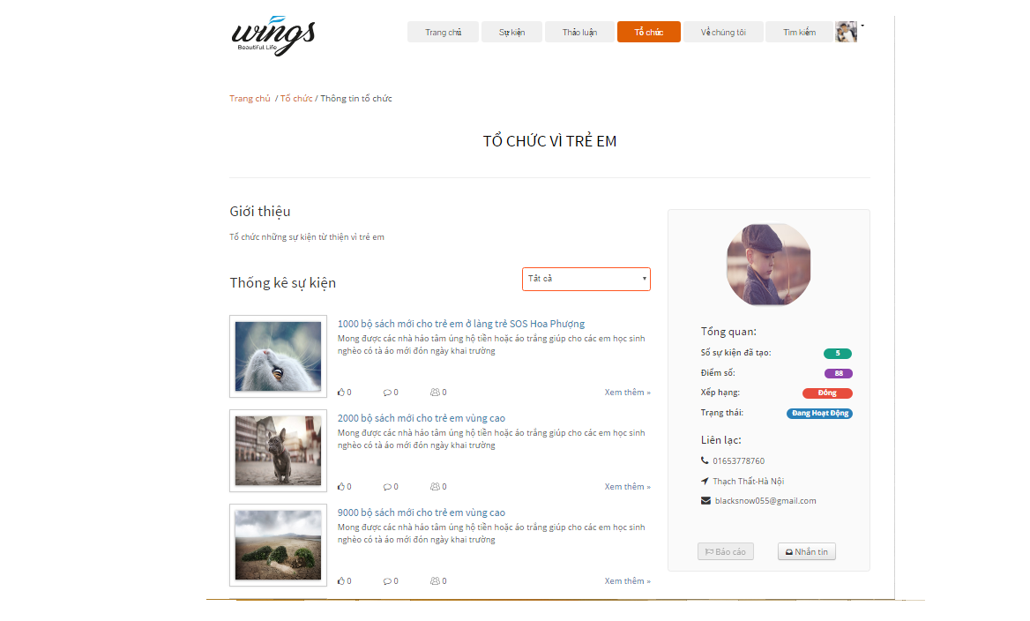

1. Organization detail

|  |  |  |  |  |  |  |  |
| --- | --- | --- | --- | --- | --- | --- | --- |
| No | Field name | Field name in Vietnamese | Type | Require | Mandatory | Max-Length | Description |
| 1 | Name of Organization | Tiêu đề | Label |  | Y |  | Name of organization |
| 2 | Description | G | Label |  | Y |  | Description about organization |
| 3 | Statistic | Nội dung | Label |  | Y |  | Statistic |
|  | Order by | Sắp xếp | Dropdownlist |  | Y |  | Click to group event by status: Ongoing, closed, all. |
| 4 | Event list | Thông tin người tạo | Label |  | Y |  | Event list which organization created |
|  | View more | Xem them | Button | Click | Y |  | Click to view event detail |
|  | Load more | Xem thêm | Button | Click |  |  | Click to view more events which organization created |
| 5 | Organization logo | Tên người tạo | Picture |  | Y |  | Creator name |
| 6 | Organization information tab | Tổng quan | Table |  | Y |  | Information of organization |
| 7 | Report | Báo cáo | Button | Click | Y |  | Report the organization |
| 8 | Message | Nhắn tin | Button | Click | Y |  | Message to organization |

1. Organization detail table

### Edit Organization

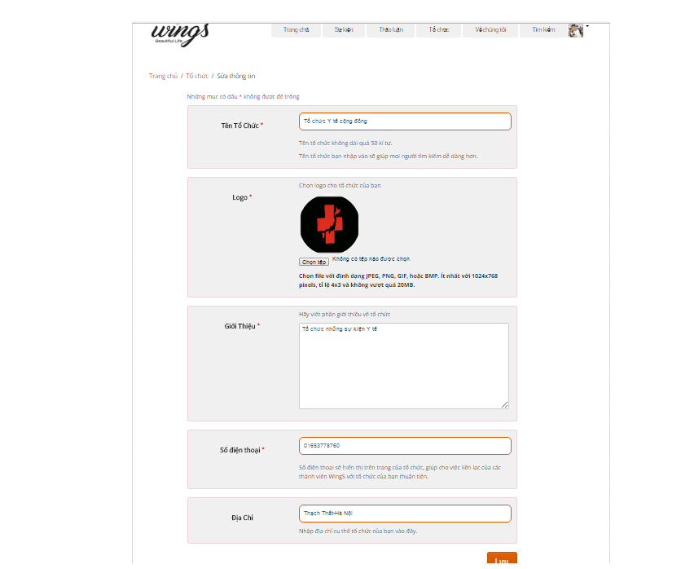

1. Edit organization screen

|  |  |  |  |  |  |  |  |
| --- | --- | --- | --- | --- | --- | --- | --- |
| No | Field name | Field name in Vietnamese | Type | Require | Mandatory | Max-Length | Description |
| 1 | Warning | Những mục có dấu * không được để trống | Text |  | Y |  | The warning about the necessary field |
| 2 | Logo | Logo | Button |  | Y |  | Logo of organization |
| 3 | Introduction | Giới Thiệu | Text |  | Y |  | Introduction about organization |
| 4 | Phone Number | Mô tả ngắn | Text |  | Y |  | Phone number |
| 5 | Email | Email | Text |  | Y |  | Email contact |
| 6 | Address | Địa chỉ | Text |  | Y |  | Address |
| 7 | Create Organization | Tạo sự kiện | Button | Click | Y |  | Edit organization |

1. Edit organization table

## User Information

### Manage profile

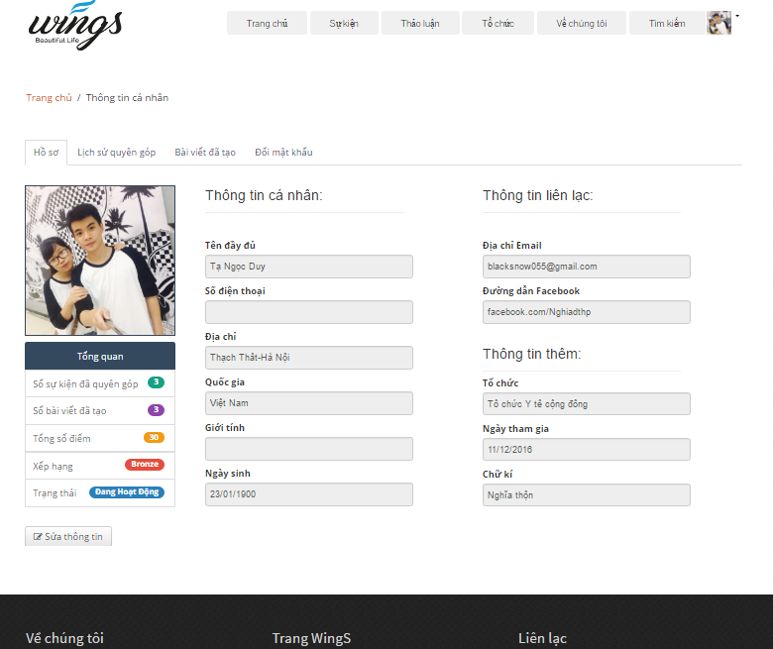

1. User profile screen

|  |  |  |  |  |  |  |  |
| --- | --- | --- | --- | --- | --- | --- | --- |
| No | Field name | Field name in Vietnamese | Type | Require | Mandatory | Max-Length | Description |
| 1 | Profile | Hồ sơ | Tab |  | Y |  | Profile tab |
| 2 | User avatar | Ảnh đại diện | URL image |  | Y |  | User avatar |
| 3 | Overview | Tổng quan | Label |  | Y |  | Overview information of user |
| 4 | Number donated event | Số sự kiện đã quyên gop | Label |  | Y |  | Display number donated event |
| 5 | Number created thread | Số bài viết đã tạo | Label |  | Y |  | Display number donated thread |
| 6 | Total point | Tổng số điểm | Label |  | Y |  | Total point |
| 7 | Rank | Xếp hạng | Label |  | Y |  | Rank of user |
| 8 | Status | Trạng thái | Label |  |  |  | Account status |
| 9 | Edit profile | Sửa thông tin | Button | Click |  |  | Click to edit profile |
| 10 | User Information | Thông tin cá nhân | Label |  |  |  | User Information |
| 11 | FullName | Tên đầy đủ | Label |  | Y |  | FullName of user |
| 12 | Phone | Số điện thoại | Label |  |  |  | Phone of user |
| 13 | Address | Địa chỉ | Label |  |  |  | Address of user |
| 14 | Country | Quốc gia | Label |  |  |  | Country of user |
| 15 | Gender | Giới tính | Label |  |  |  | Gender |
| 16 | DOB | Ngày sinh | Label |  |  |  | Date of birth |
| 17 | Contact information | Thông tin liên lạc | Label |  |  |  | Contact information |
| 18 | Email | Địa chỉ email | Label |  | Y |  | Email link |
| 19 | Facebook | Địa chỉ facebook | Label |  | Y |  | Facebook link |
| 20 | Organization | Tổ chức | Label |  |  |  | Organization of user |
| 21 | Created date | Ngày tham gia | Label |  | Y |  | Created date |
| 22 | Sign | Chữ ký | Label |  |  |  | Sign of user |

1. User profile table

### Edit profile

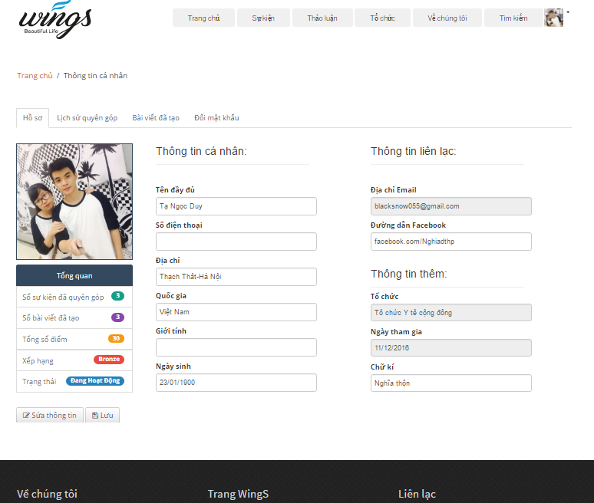

1. Edit profile screen

|  |  |  |  |  |  |  |  |
| --- | --- | --- | --- | --- | --- | --- | --- |
| No | Field name | Field name in Vietnamese | Type | Require | Mandatory | Max-Length | Description |
| 1 | Profile | Hồ sơ | Tab |  | Y |  | Profile tab |
| 2 | User avatar | Ảnh đại diện | URL image |  | Y |  | User avatar |
| 3 | Overview | Tổng quan | Label |  | Y |  | Overview information of user |
| 4 | Number donated event | Số sự kiện đã quyên gop | Label |  | Y |  | Display number donated event |
| 5 | Number created thread | Số bài viết đã tạo | Label |  | Y |  | Display number donated thread |
| 6 | Total point | Tổng số điểm | Label |  | Y |  | Total point |
| 7 | Rank | Xếp hạng | Label |  | Y |  | Rank of user |
| 8 | Status | Trạng thái | Label |  |  |  | Account status |
| 9 | Edit profile | Sửa thông tin | Button | Click |  |  | Click to edit profile |
| 10 | Save | Lưu thông tin | Button | Click |  |  | Click to save the changing |
| 11 | User Information | Thông tin cá nhân | Label |  |  |  | User Information |
| 12 | FullName | Tên đầy đủ | Text |  | Y |  | FullName of user |
| 13 | Phone | Số điện thoại | Text |  |  |  | Phone of user |
| 14 | Address | Địa chỉ | Text |  |  |  | Address of user |
| 15 | Country | Quốc gia | Text |  |  |  | Country of user |
| 16 | Gender | Giới tính | Text |  |  |  | Gender |
| 17 | DOB | Ngày sinh | Text |  |  |  | Date of birth |
| 18 | Contact information | Thông tin liên lạc | Label |  |  |  | Contact information |
| 19 | Email | Địa chỉ email | Label |  | Y |  | Email link |
| 20 | Facebook | Địa chỉ facebook | Label |  | Y |  | Facebook link |
| 21 | Organization | Tổ chức | Label |  |  |  | Organization of user |
| 22 | Created date | Ngày tham gia | Label |  | Y |  | Created date |
| 23 | Sign | Chữ ký | Text |  |  |  | Sign of user |

1. Edit profile table

### Manage donation

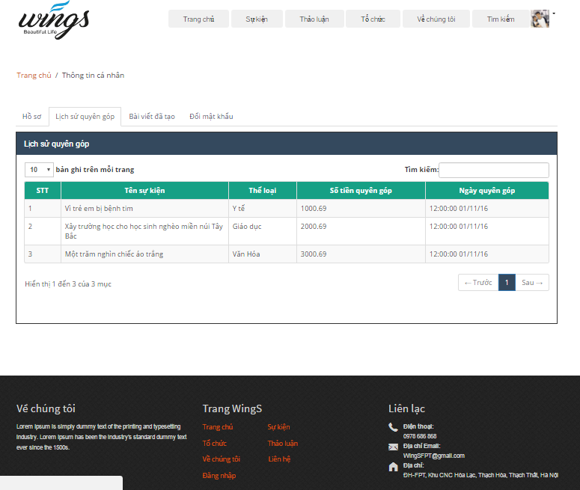

1. Donation screen

|  |  |  |  |  |  |  |  |
| --- | --- | --- | --- | --- | --- | --- | --- |
| No | Field name | Field name in Vietnamese | Type | Require | Mandatory | Max-Length | Description |
| 1 | Donation record | Lịch sử quyên góp | Tab |  | Y |  | Donation record tab |
| 2 | Record number | Số bản ghi mỗi trang | Label |  | Y |  | Number of record (event) |
| 3 | Search | Tìm kiếm | Text |  | Y |  | Search event by keyword |
| 4 | Number | Số thứ tự | Label |  | Y |  | Event number |
| 5 | Event name | Tên sự kiện | Label |  | Y |  | Event name |
| 6 | Event type | Loại sự kiện | Label |  | Y |  | Event type |
| 7 | Money donated | Số tiền đã quyên góp | Label |  | Y |  | Amount of money which user donated |
| 8 | Donated date | Ngày quyên góp | Label |  | Y |  | Date when user donated |
| 9 | Paging | Trang | Button | Click | Y |  | Paging |

1. Donation table

### Manage created thread

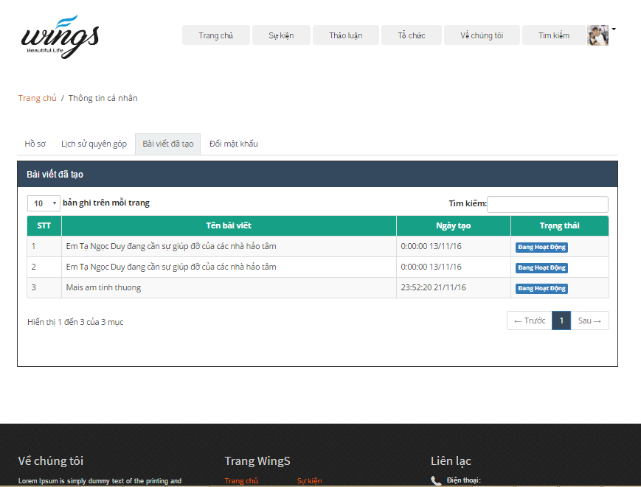

1. Created thread screen

|  |  |  |  |  |  |  |  |
| --- | --- | --- | --- | --- | --- | --- | --- |
| No | Field name | Field name in Vietnamese | Type | Require | Mandatory | Max-Length | Description |
| 1 | Created thread | Bài viết đã tạo | Tab |  | Y |  | Created thread tab |
| 2 | Record number | Số bản ghi mỗi trang | Label |  | Y |  | Number of record (thread) |
| 3 | Search | Tìm kiếm | Text |  | Y | 100 | Search thread by keyword |
| 4 | Number | Số thứ tự | Label |  | Y |  | Thread number |
| 5 | Thread title | Tên bài thảo luận | Label |  | Y |  | Thread title |
| 7 | Created date | Ngày tạo | Label |  | Y |  | Date when user created thread |
| 8 | Status | Tình trạng | Label |  | Y |  | Status of thread |
| 9 | Paging | Trang | Button | Click | Y |  | Paging |

1. Created thread table

### Change password

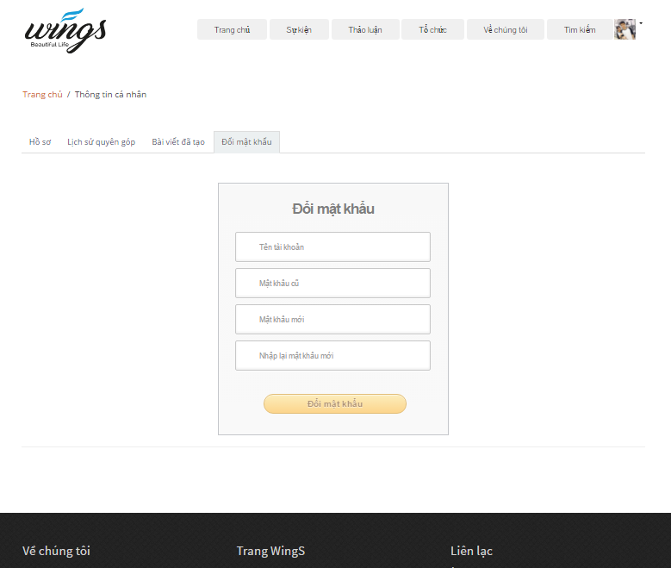

1. Change password screen

|  |  |  |  |  |  |  |  |
| --- | --- | --- | --- | --- | --- | --- | --- |
| No | Field name | Field name in Vietnamese | Type | Require | Mandatory | Max-Length | Description |
| 1 | Change password | Đổi mật khẩu | Tab |  | Y |  | Change password tab |
| 2 | Change password | Đổi mật khẩu | Label |  | Y |  | Number of record (thread) |
| 3 | UserName | Tìm kiếm | Text |  | Y | 100 | Search thread by keyword |
| 4 | Old Password | Mật khẩu cũ | Label |  | Y |  | Current password |
| 5 | New Password | Mật khẩu mới | Label |  | Y |  | New password which user want to change |
| 7 | Confirm new password | Xác nhận mật khẩu | Label |  | Y |  | Confirm new password |
| 8 | Change password | Đổi mật khẩu | Button | Click | Y |  | Change password button |

1. Change password table

## Message

### Message view

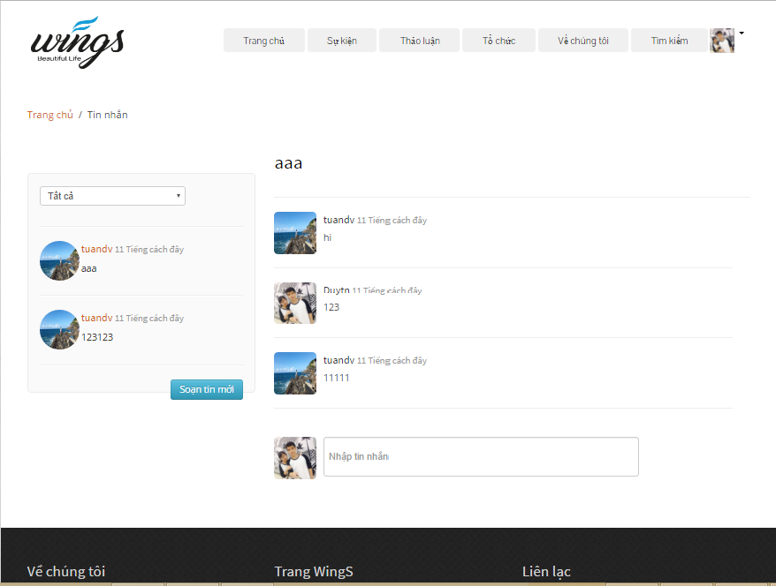

1. View message screen

|  |  |  |  |  |  |  |  |
| --- | --- | --- | --- | --- | --- | --- | --- |
| No | Field name | Field name in Vietnamese | Type | Require | Mandatory | Max-Length | Description |
| 1 | Group Message | Loại tin nhắn | Drop downlist |  | Y |  | Group type of message |
| 2 | List message | Danh sách tin nhắn | List |  | Y |  | All list message of user |
| 3 | New Message | Viết tin nhắn mới | Button |  | Y | 100 | Create new message |
| 4 | Message title | Tiêu đề tin nhắn | Label |  | Y |  | Message title |
| 5 | Message content | Nội dung tin nhắn | Label |  | Y |  | Message content |
| 7 | Message | Viết tin nhắn | Text |  | Y |  | Write new message |

1. View message table

### Send message

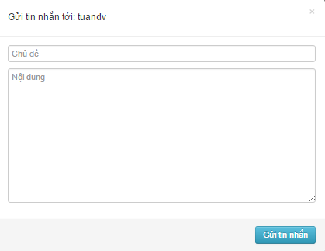

1. View message screen

|  |  |  |  |  |  |  |  |
| --- | --- | --- | --- | --- | --- | --- | --- |
| No | Field name | Field name in Vietnamese | Type | Require | Mandatory | Max-Length | Description |
| 1 | Receiver | Người nhận | Label |  | Y |  | People who receive the message |
| 2 | Message title | Tiêu đề tin nhắn | Label |  | Y |  | Message title |
| 3 | Message content | Nội dung tin nhắn | Label |  | Y |  | Message content |
| 4 | Send Message | Gửi tin nhắn | Button |  | Y |  | Send new message |

1. Send message table

## Donate

### Donate

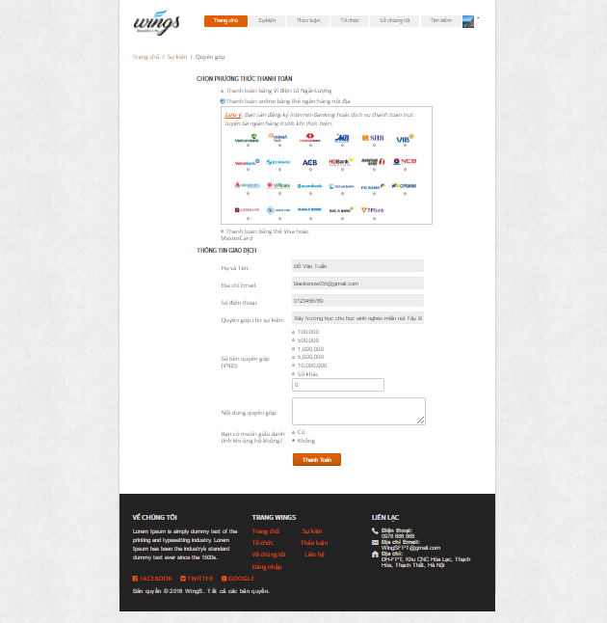

1. Donate Event screen

|  |  |  |  |  |  |  |  |  |
| --- | --- | --- | --- | --- | --- | --- | --- | --- |
| No | Field name | | Field name in Vietnamese | Type | Require | Mandatory | Max-Length | Description |
| 1 | Name of Event | Tên sự kiện | | Hyperlink | Click | Y |  | Name of Event |
| 2 | Name of organization | Tên người tổ chức | | Hyperlink | Click | Y |  | Display information of organization |
| 3 | Money | Số tiền ủng hộ | | Number |  | Y |  | Money to donate |
| 4 | Donate | Ủng hộ | | Button | Click | Y |  | Click to link to payment page |

1. Donate Event

### Payment event

1. Payment Event screen

|  |  |  |  |  |  |  |  |  |
| --- | --- | --- | --- | --- | --- | --- | --- | --- |
| No | | Field name | Field name in Vietnamese | Type | Require | Mandatory | Max-Length | Description |
| 1 | Avatar | | Ảnh đại điện | Image |  |  |  | Display avartar |
| 2 | Full name | | Tên đầy đủ | Text |  | Y |  | Full name of backer |
| 3 | Email | | Email | Text |  | Y |  | Email of backer |
| 4 | Address | | Địa chỉ | Text |  | Y |  | Address of backer |
| 5 | Phone number | | Số điện thoại | Text |  | Y |  | Phone number of backer |
| 6 | More info | | Thông tin thêm | Textarea |  |  |  | More information about reward,… |
| 7 | Back | | Ủng hộ | Button |  | Y |  | Back Event |

1. Payment Event

## ADMIN

### Login

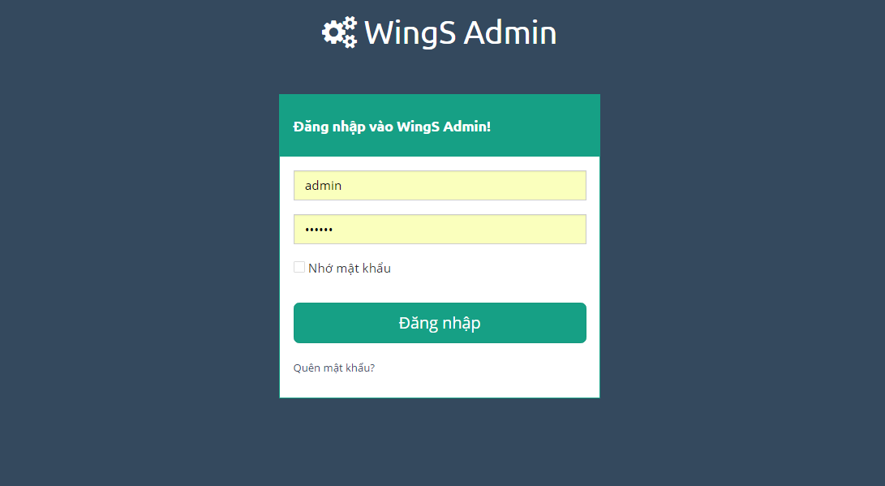

1. Login screen

|  |  |  |  |  |  |  |  |
| --- | --- | --- | --- | --- | --- | --- | --- |
| No | Field name | Field name in Vietnamese | Type | Require | Mandatory | Max-Length | Description |
| 1 | Username or email | Tên tài khoản hoặc email | Text box | Type | Y |  | Username or Email of Admin |
| 2 | Password | Mật khẩu | Text box | Type | Y |  | Password of registered Admin |
| 3 | Remember Me | Lưu đăng nhập | Check box | Click | Y |  | Save login information |
| 4 | Login | Đăng nhập | Button | Click | Y |  | Login |

1. Login

### Dashboard

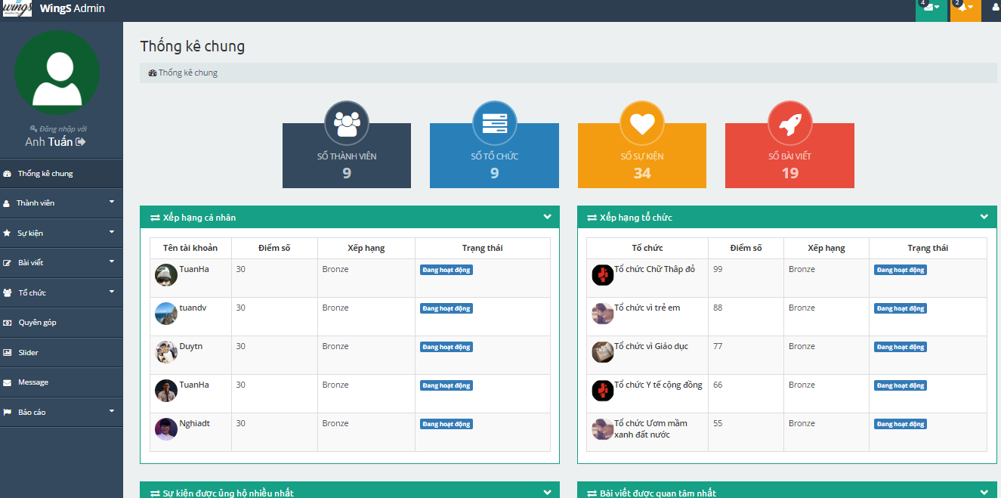

1. Dash board

|  |  |  |  |  |  |  |  |
| --- | --- | --- | --- | --- | --- | --- | --- |
| No | Field name | Field name in Vietnamese | Type | Require | Mandatory | Max-Length | Description |
| 1 | Total users | Số thành viên | Label |  | Y |  | Total users registed |
| 2 | Total Organization | Số tổ chức | Label |  | Y |  | Total Organization created |
| 3 | Total Event | Số sự kiện | Label |  | Y |  | Total Event created |
| 4 | Total Thread | Số bài viết | Label |  | Y |  | Total Thread created |
| 5 | Top User | Thành viên có số điểm cao nhất | Table |  | Y |  | Table top 5 users has highest point |
| 6 | Top Organization | Tổ chức có số điểm cao nhất | Table |  | Y |  | Table top 5 organizations has highest point |
| 7 | Top Thread | Bài viết được quan tâm nhiều nhất | Table |  | Y |  | Table top 5 threads have most like |
| 8 | Top donor | Người dùng ủng hộ nhiều nhất | Table |  | Y |  | Table top 5 donors |
| 9 | Recently Event | Sự kiện vừa được quyên góp | Table |  | Y |  | Event which has been donated recently |

1. Dashboard

### Users

#### Users dashboard

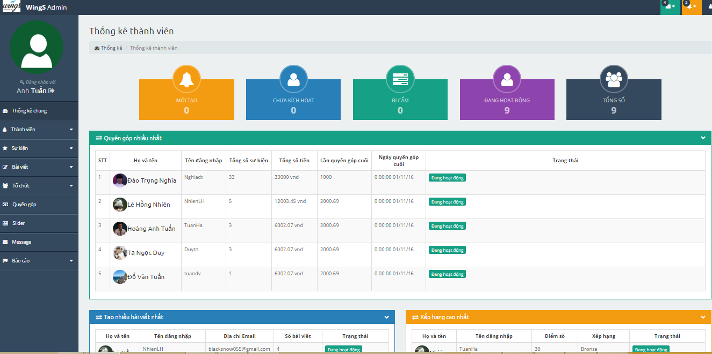

1. Users dashboard screen

|  |  |  |  |  |  |  |  |
| --- | --- | --- | --- | --- | --- | --- | --- |
| No | Field name | Field name in Vietnamese | Type | Require | Mandatory | Max-Length | Description |
| 1 | Total new users | Người dùng mới | Label |  | Y |  | Total new users |
| 3 | Total users deactive | Người dùng chưa kích hoạt | Label |  | Y |  | Total user NOT Active |
| 3 | Total users be banned | Người dùng bị cấm | Label |  | Y |  | Total user be banned |
| 4 | Total users active | Người dùng đang hoạt động | Label |  | Y |  | Total user Active |
| 5 | Total users | Tổng số người dùng | Label |  | Y |  | Total users registed |
| 6 | Top donation | Quyên góp nhiều nhất | Table |  | Y |  | Top 5 donors with highest donation |
| 7 | Most user backed | Tạo nhiều bài viết nhất | Table |  | Y |  | Top 5 users with most created thread |
| 8 | New users | Xếp hạng cao nhất | Table |  | Y |  | Top 5 user with highest point |

1. Users dashboard

#### Users list

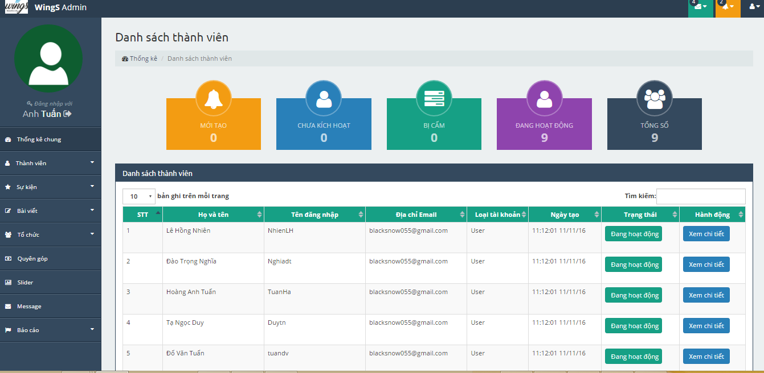

1. Users list screen

|  |  |  |  |  |  |  |  |
| --- | --- | --- | --- | --- | --- | --- | --- |
| No | Field name | Field name in Vietnamese | Type | Require | Mandatory | Max-Length | Description |
| 1 | Total new users | Người dùng mới | Label |  | Y |  | Total new users |
| 3 | Total users deactive | Người dùng chưa kích hoạt | Label |  | Y |  | Total user NOT Active |
| 3 | Total users be banned | Người dùng bị cấm | Label |  | Y |  | Total user be banned |
| 4 | Total users active | Người dùng đang hoạt động | Label |  | Y |  | Total user Active |
| 5 | Total users | Tổng số người dùng | Label |  | Y |  | Total users registed |
| 6 | View (icon) | Xem (biểu tượng) | Button | Click | Y |  | Link to profile of user |
| 7 | Active (icon) | Mở khóa (biểu tượng) | Button | Click | Y |  | Unlock/Active user |
| 8 | Deactive (icon) | Khóa (biểu tượng) | Button | Click | Y |  | Lock/Deactive user |

1. Users list

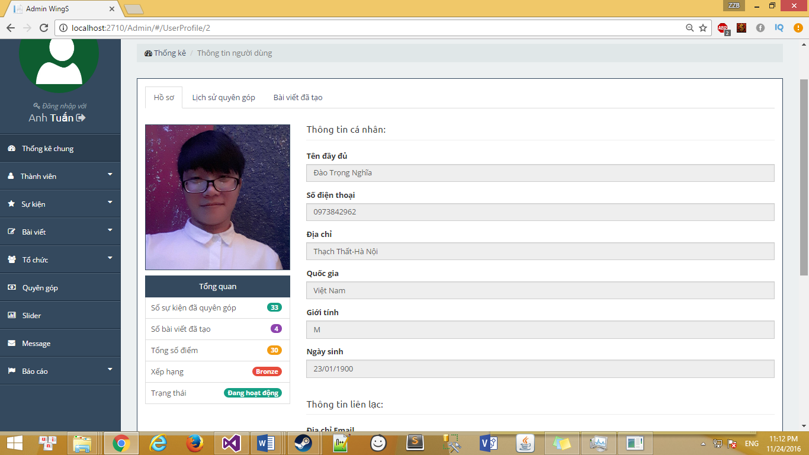

1. User’profile screen

### Event

#### Event dashboard

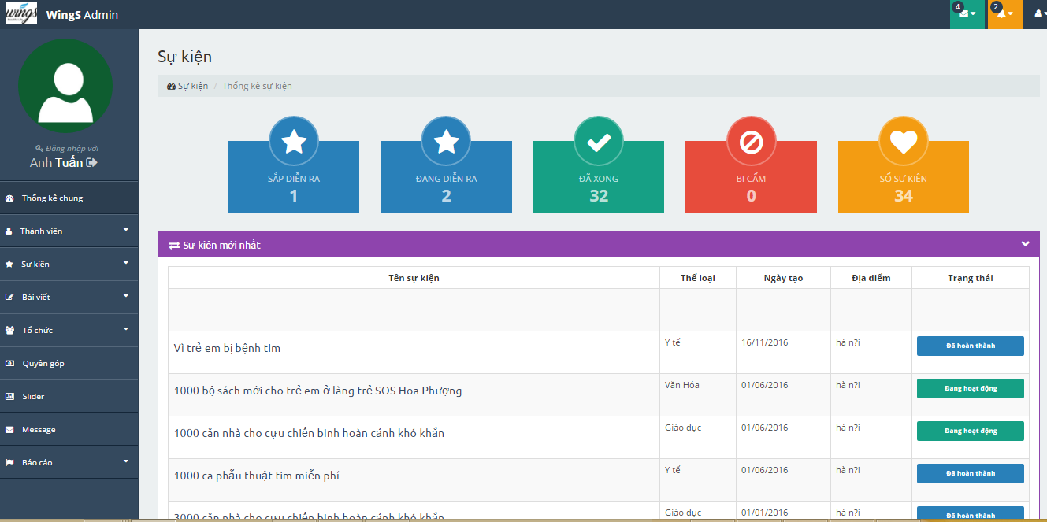

1. Event dashboard screen

|  |  |  |  |  |  |  |  |
| --- | --- | --- | --- | --- | --- | --- | --- |
| No | Field name | Field name in Vietnamese | Type | Require | Mandatory | Max-Length | Description |
| 1 | Total Event upcoming | Số sự kiện sắp diễn ra | Label |  | Y |  | Total Event upcoming |
| 2 | Total Event running | Số sự kiện đang diễn ra | Label |  | Y |  | Total Event running |
| 3 | Total Event Closed | Số sự kiện đã xong | Label |  | Y |  | Total Event Closed |
| 4 | Total Event be banned | Số sự kiện bị cấm | Label |  | Y |  | Total Event be banned |
| 5 | Total Event | Tống số sự kiện | Label |  | Y |  | Total Event |
| 6 | Top New Events | Danh sách các sự kiện mới | Table |  | Y |  | List Events |
| 7 | Top Donation Events | Danh sách sự kiện ủng hộ nhiều nhất | Table |  | Y |  | List Events |

1. Event dashboard

#### Events list

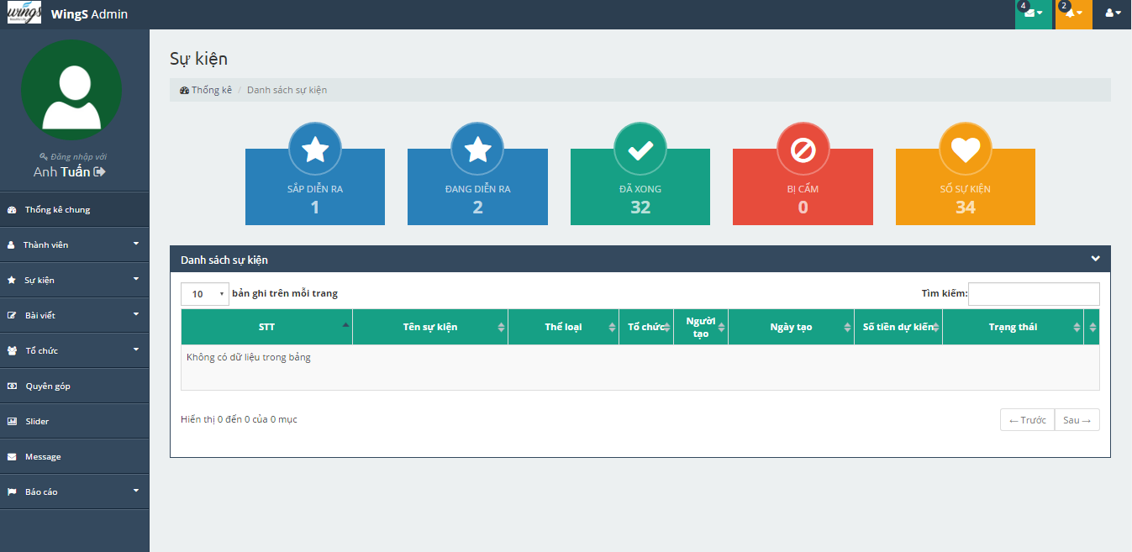

1. Events list screen

|  |  |  |  |  |  |  |  |
| --- | --- | --- | --- | --- | --- | --- | --- |
| No | Field name | Field name in Vietnamese | Type | Require | Mandatory | Max-Length | Description |
| 1 | Order number | Số thứ tự | Label |  | Y |  | Order number |
| 2 | Event name | Tên sư kiện | Label |  | Y |  | Event name |
| 3 | Event type | Thể loại sự kiện | Label |  | Y |  | Event type |
| 4 | Organization name | Tên tổ chức | Label |  | Y |  | Organization name |
| 5 | Creator | Người tạo | Label |  | Y |  | Creator |
| 6 | Created date | Ngày tạo | Label |  | Y |  | Created date |
| 7 | Expected money | Số tiền dự kiến | Label |  | Y |  | Expected money |
| 8 | Status | Trạng thái | Button | Click | Y |  | Status |

1. Event list

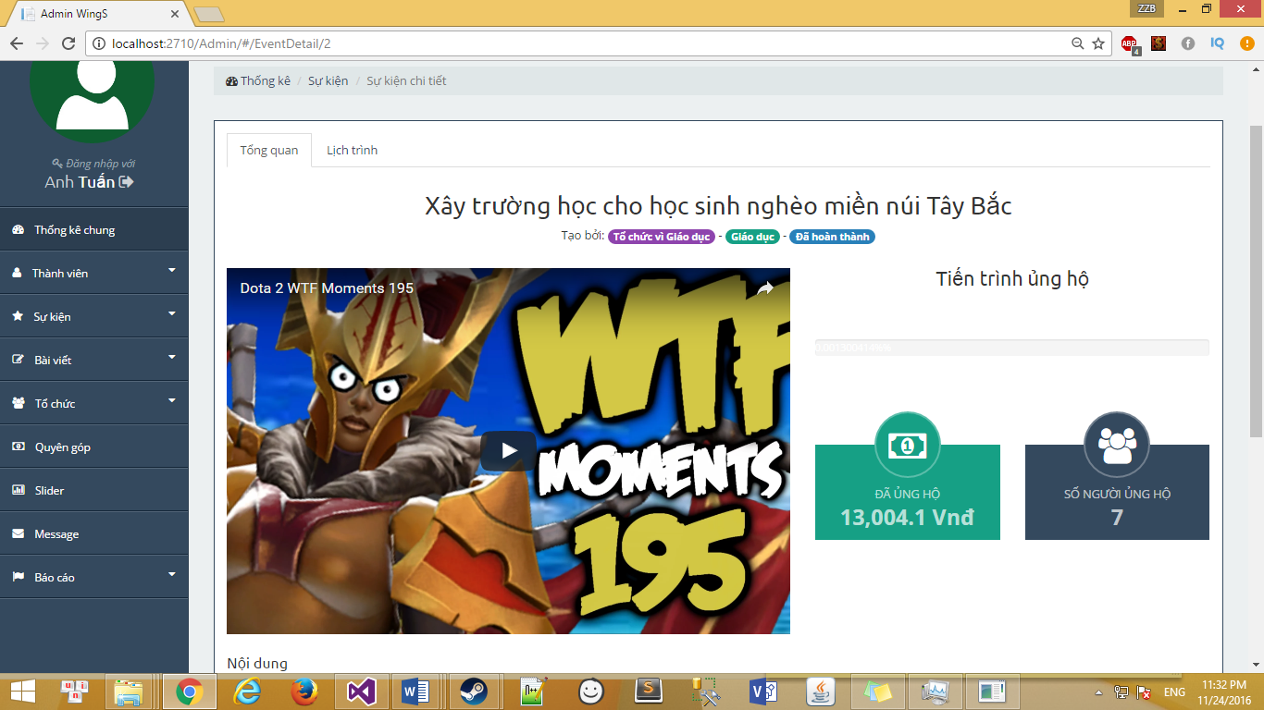

1. Event detail screen

|  |  |  |  |  |  |  |  |
| --- | --- | --- | --- | --- | --- | --- | --- |
| No | Field name | Field name in Vietnamese | Type | Require | Mandatory | Max-Length | Description |
| 1 | Infomation | Tổng quan | Tab |  | Y |  | Profile |
| 2 | Schedule | Lịch trình | Tab |  | Y |  | Backed Event |
| 3 | Created Event | Cập nhật | Tab |  | Y |  | Created Event |

1. Event detail

#### Event category

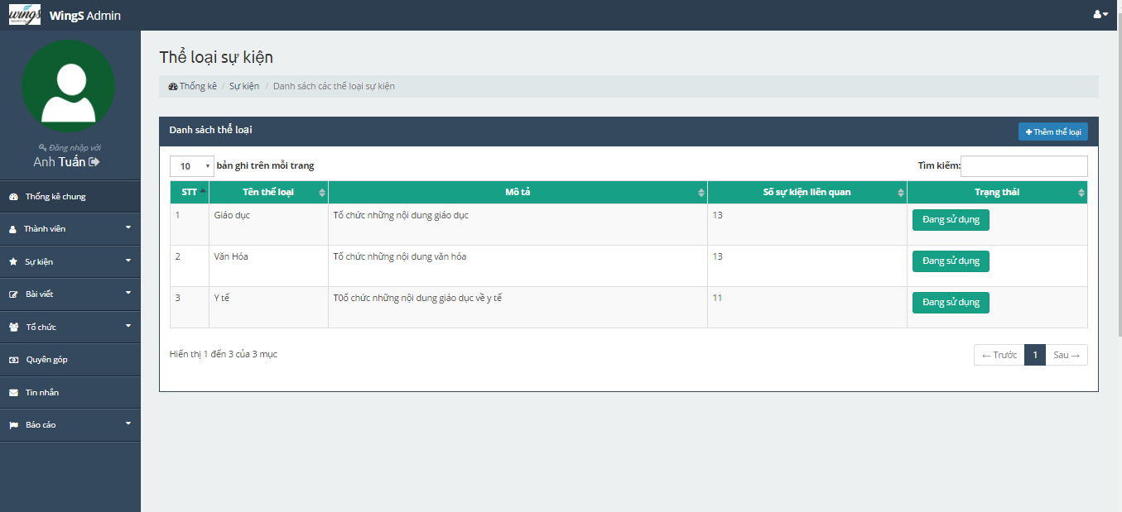

1. Event type screen

|  |  |  |  |  |  |  |  |
| --- | --- | --- | --- | --- | --- | --- | --- |
| No | Field name | Field name in Vietnamese | Type | Require | Mandatory | Max-Length | Description |
| 1 | Order number | Số thứ tự | Label |  | Y |  | Order number |
| 2 | Event type name | Tên thể loại | Label |  | Y |  | Event type names |
| 3 | Description | Thể loại sự kiện | Label |  | Y |  | Description |
| 4 | Numbers of event relate | Số sự kiện liên quan | Label |  | Y |  | Numbers of event relate |
| 5 | Status | Trạng thái | Button | Click | Y |  | Status |
| 6 | Add event type | Thêm thể loại | Button | Click | Y |  | Add event type |

1. Event type

### Thread

#### Thread dashboard

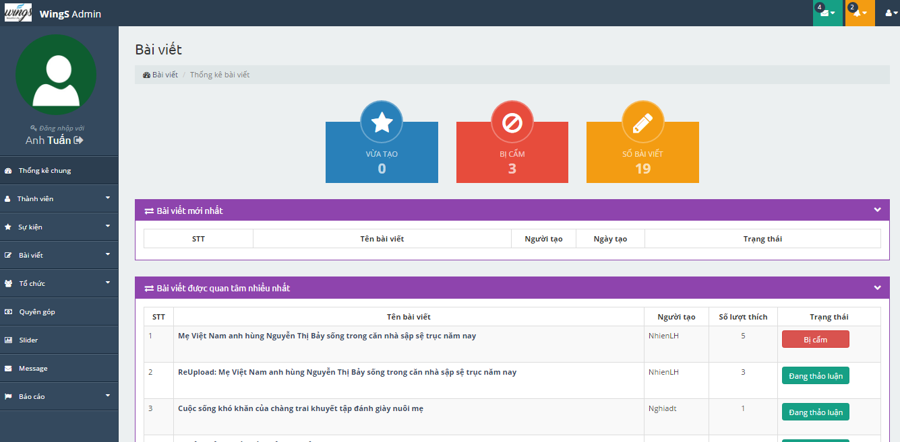

1. Thread dashboard screen

|  |  |  |  |  |  |  |  |
| --- | --- | --- | --- | --- | --- | --- | --- |
| No | Field name | Field name in Vietnamese | Type | Require | Mandatory | Max-Length | Description |
| 1 | Total Thread recently | Số sự bài viết vừa tạo | Label |  | Y |  | Total Thread upcoming |
| 2 | Total Thread running | Số bài viết bị cấm | Label |  | Y |  | Total Thread running |
| 3 | Total Thread | Tống số bài viết | Label |  | Y |  | Total Thread |
| 4 | Top New Thread | Danh sách các bài viết mới | Table |  | Y |  | Top New Thread |
| 5 | Top interested thread | Danh sách bài viết được quan tâm | Table |  | Y |  | Top interested thread |

1. Thread dashboard

#### Thread list

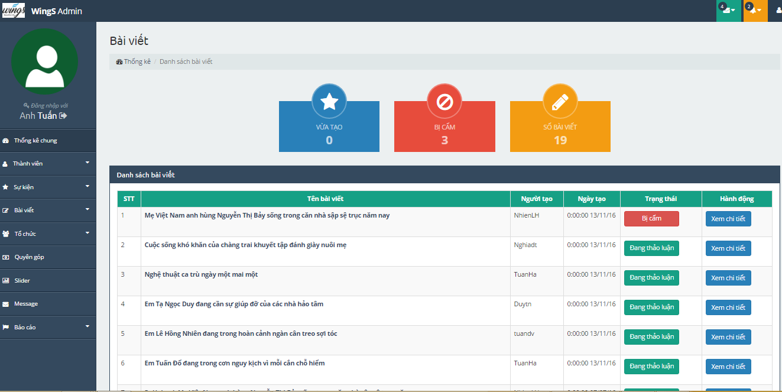

1. Thread list screen

|  |  |  |  |  |  |  |  |
| --- | --- | --- | --- | --- | --- | --- | --- |
| No | Field name | Field name in Vietnamese | Type | Require | Mandatory | Max-Length | Description |
| 1 | Order number | Số thứ tự | Label |  | Y |  | Order number |
| 2 | Name of thread | Tên bài viết | Label |  | Y |  | Name of thread |
| 3 | Creator | Người tạo |  |  | Y |  | Creator |
| 4 | Created date | Ngày tạo | Table |  | Y |  | Created date |
| 5 | Status | Trạng thái | Button | Click | Y |  | Status |
| 6 | Action | Hành động | Button | Click | Y |  | Action |

1. Thread list

### Organization

#### Organization dashboard

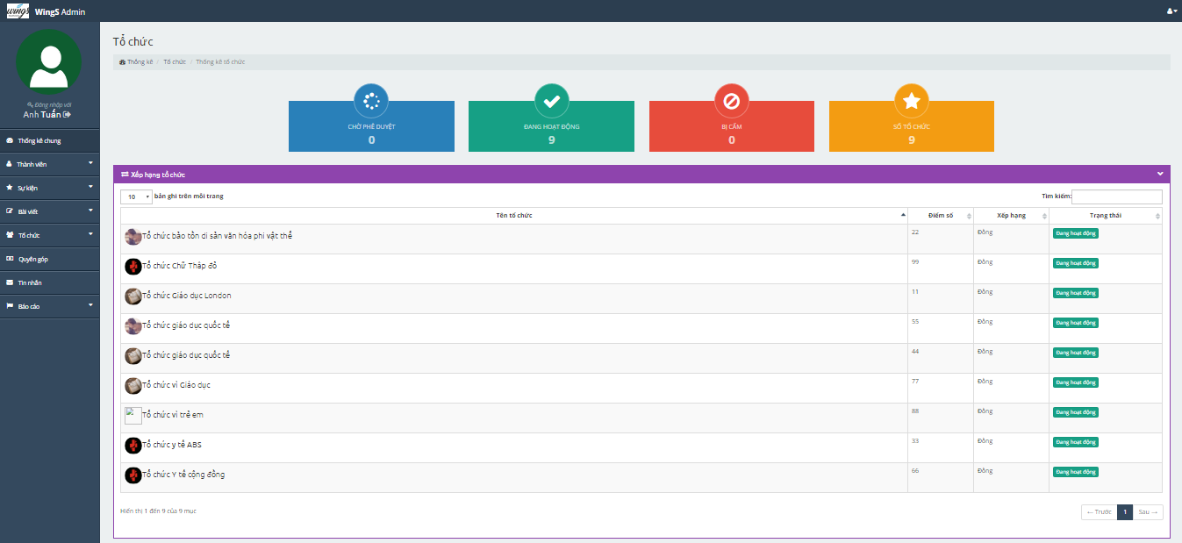

1. Organization dashboard screen

|  |  |  |  |  |  |  |  |
| --- | --- | --- | --- | --- | --- | --- | --- |
| No | Field name | Field name in Vietnamese | Type | Require | Mandatory | Max-Length | Description |
| 1 | Total pending approval | Số tổ chức chờ xử lý | Label |  | Y |  | Total pending approval |
| 2 | Total running | Số tổ chức đang hoạt động | Label |  | Y |  | Total running |
| 3 | Total be banned | Số tổ chức bị cấm | Label |  | Y |  | Total be banned |
| 5 | Total | Số tổ chức | Label |  | Y |  | Total |
| 6 | Rank of organization | Xếp hạng tổ chức | Table |  | Y |  | Rank of organization |
| 7 | New organization | Tổ chức mới nhất | Table |  | Y |  | New organization |

1. Organization dashboard

#### Organization list

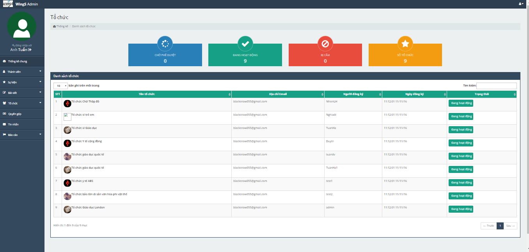

1. Organization list screen

|  |  |  |  |  |  |  |  |
| --- | --- | --- | --- | --- | --- | --- | --- |
| No | Field name | Field name in Vietnamese | Type | Require | Mandatory | Max-Length | Description |
| 1 | Order number | Số thứ tự | Label |  | Y |  | Order number |
| 2 | Name of organization | Tên tổ chức | Label |  | Y |  | Name of organization |
| 3 | Email | Địa chỉ email | Label |  | Y |  | Email |
| 4 | Register | Người đăng ký | Label |  | Y |  | Register |
| 5 | Registed date | Ngày đăng ký | Label |  | Y |  | Registed date |
| 6 | Status | Trạng thái | Button | Click | Y |  | Status |

1. Organization list

### Donate

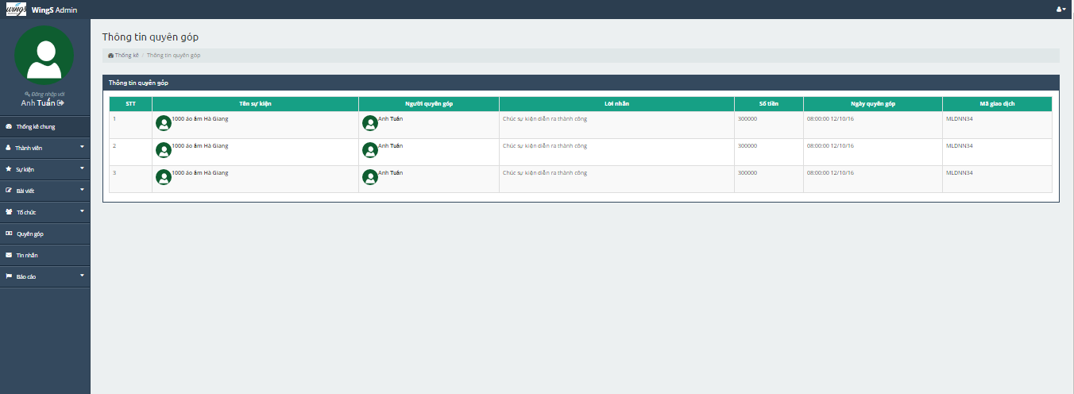

1. Donate list screen

|  |  |  |  |  |  |  |  |
| --- | --- | --- | --- | --- | --- | --- | --- |
| No | Field name | Field name in Vietnamese | Type | Require | Mandatory | Max-Length | Description |
| 1 | Order number | Số thứ tự | Label |  | Y |  | Order number |
| 2 | Name of event | Tên sự kiện | Label |  | Y |  | Name of event |
| 3 | Donater | Người quyên góp | Label |  | Y |  | Donater |
| 4 | Content | Lời nhắn | Label |  | Y |  | Content |
| 5 | Number of money | Số tiềns | Label |  | Y |  | Number of money |
| 6 | Donated date | Ngày quyên góp | Label |  |  |  | Donated date |
| 7 | Trading code | Mã giao dịch | Label |  | Y |  | Trading code |

1. Donate list

### Message

N/A

### Report

#### Report user

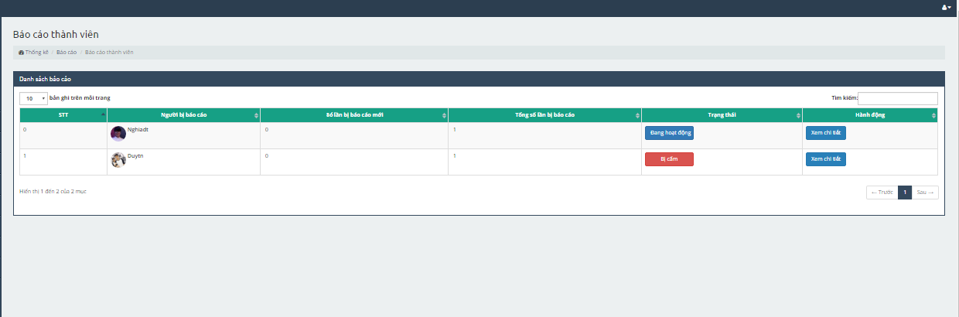

1. Report user management screen

|  |  |  |  |  |  |  |  |
| --- | --- | --- | --- | --- | --- | --- | --- |
| No | Field name | Field name in Vietnamese | Type | Require | Mandatory | Max-Length | Description |
| 1 | Order number | Số thứ tự | Lable |  | Y |  | Order number |
| 2 | User has been reported | Người bị báo cáo | Lable |  | Y |  | User has been reported |
| 3 | Numbers of reported | Số lần bị báo cáo | Lable |  | Y |  | Numbers of reported |
| 4 | Status | Trạng thái | Lable |  | Y |  | Status |
| 5 | Action | Hành động | Button | Click | Y |  | Action |

1. Report user management

#### Report organization

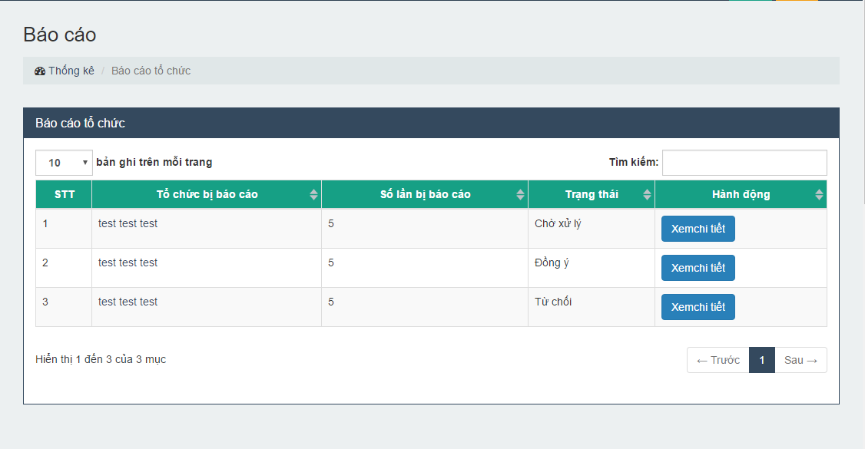

1. Report Organization management screen

|  |  |  |  |  |  |  |  |
| --- | --- | --- | --- | --- | --- | --- | --- |
| No | Field name | Field name in Vietnamese | Type | Require | Mandatory | Max-Length | Description |
| 1 | Order number | Số thứ tự | Lable |  | Y |  | Order number |
| 2 | Organization has been reported | Tổ chức bị báo cáo | Lable |  | Y |  | Organization has been reported |
| 3 | Numbers of reported | Số lần bị báo cáo | Lable |  | Y |  | Numbers of reported |
| 4 | Status | Trạng thái | Lable |  | Y |  | Status |
| 5 | Action | Hành động | Button | Click | Y |  | Action |

1. Report Event management

#### Report thread

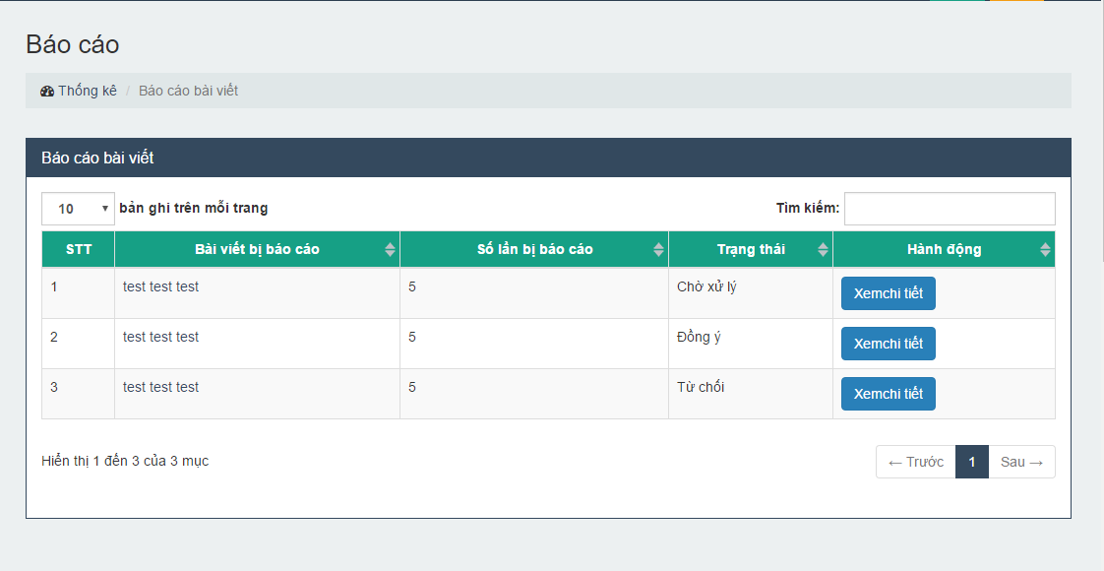

1. Report thread management scren

|  |  |  |  |  |  |  |  |
| --- | --- | --- | --- | --- | --- | --- | --- |
| No | Field name | Field name in Vietnamese | Type | Require | Mandatory | Max-Length | Description |
| 1 | Order number | Số thứ tự | Lable |  | Y |  | Order number |
| 2 | Thread has been reported | Bài viết bị báo cáo | Lable |  | Y |  | Thread has been reported |
| 3 | Numbers of reported | Số lần bị báo cáo | Lable |  | Y |  | Numbers of reported |
| 4 | Status | Trạng thái | Lable |  | Y |  | Status |
| 5 | Action | Hành động | Button | Click | Y |  | Action |

1. Report thread management

#### Report event

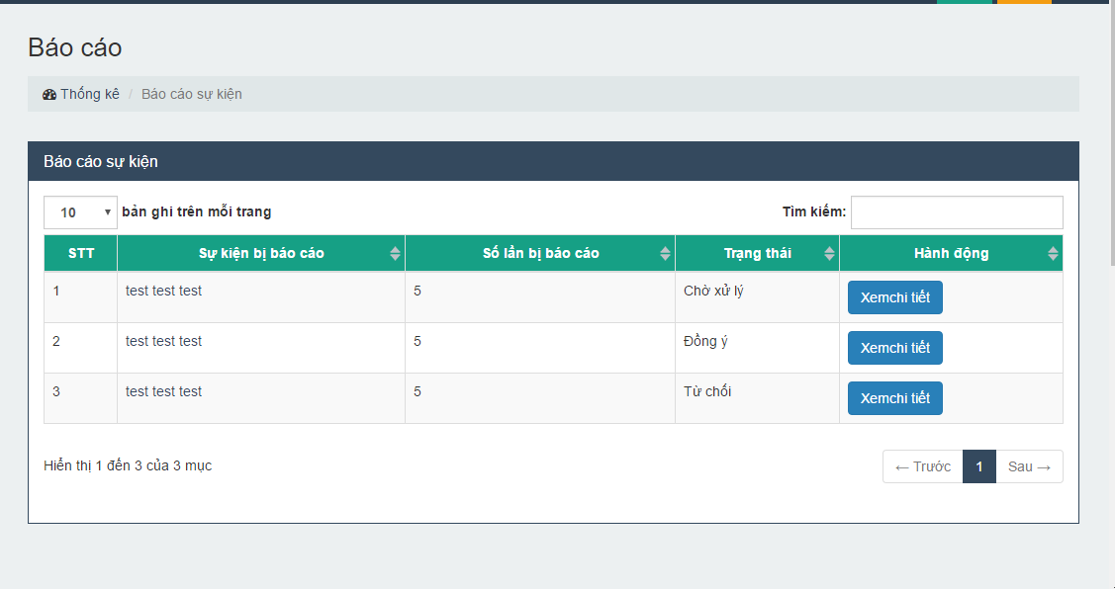

1. Report event management screen

|  |  |  |  |  |  |  |  |
| --- | --- | --- | --- | --- | --- | --- | --- |
| No | Field name | Field name in Vietnamese | Type | Require | Mandatory | Max-Length | Description |
| 1 | Order number | Số thứ tự | Lable |  | Y |  | Order number |
| 2 | Event has been reported | Sự kiện bị báo cáo | Lable |  | Y |  | Event has been reported |
| 3 | Numbers of reported | Số lần bị báo cáo | Lable |  | Y |  | Numbers of reported |
| 4 | Status | Trạng thái | Lable |  | Y |  | Status |
| 5 | Action | Hành động | Button | Click | Y |  | Action |

1. Report event management